Analog VFO for a wide interval of frequencies
by Daniel Romila VE7LCG
I was looking for an analogue oscillator for my receiver and transmitter projects. This VFO was supposed to complement my Arduino signal generator, based on a Si5351 and Arduino Nano. I just wanted to try the projects with the digital signal generator first, but also to be capable to show in function the same projects with a classic kind of VFO, something analog, stable and with a signal strong enough to be shown on a frequency meter, which for me means a signal bigger than 60 mVpp – let’s say 100 mVpp, just to be on the safe side. And once I got to 100 mVpp, maybe several Vpp would be even better, to be capable to use diodes ring mixers and dual gate MOS-FET mixers, since they require a strong signal.
I found the following schematic, on page 91 from G-QRP Club Circuits Handbook from 1983:
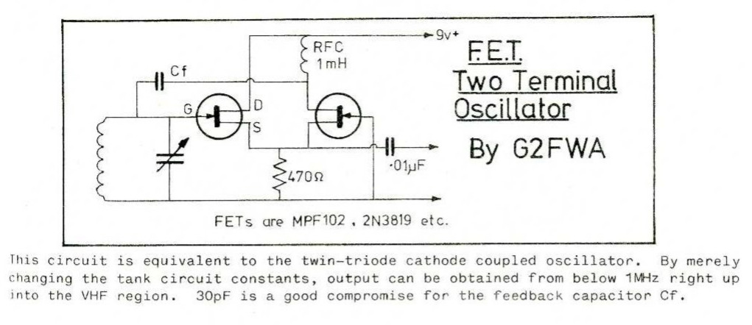
I liked the simplicity of the circuit, so I decided to work on it. I drew it in Multisim 14.3, modified it and simulated it:
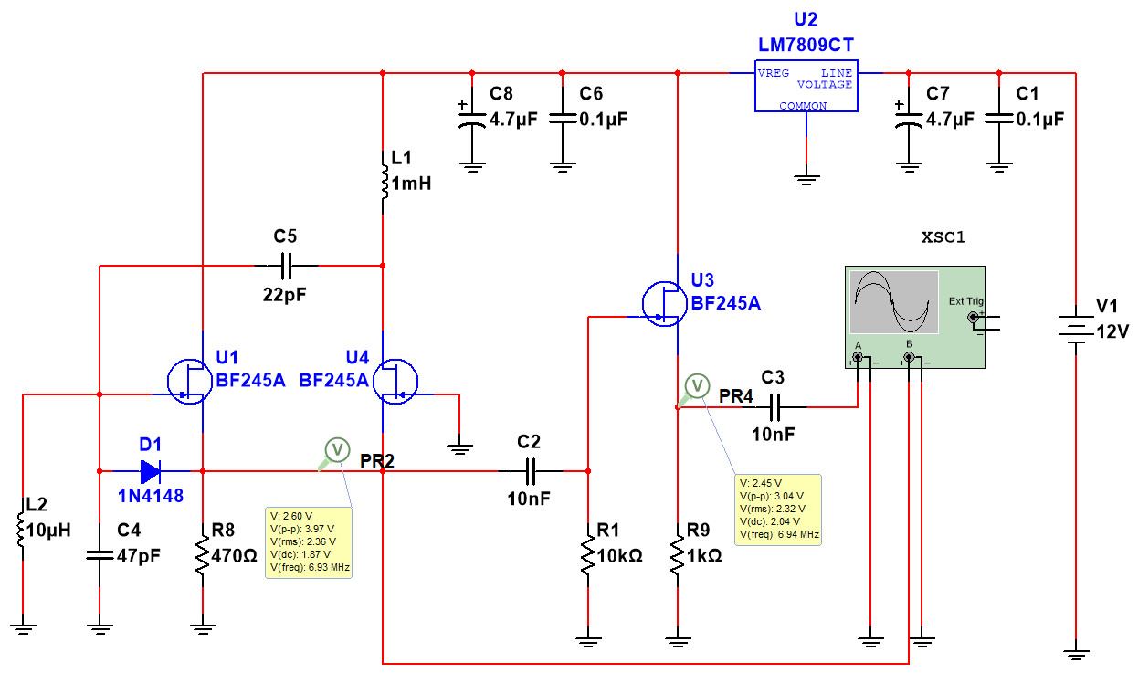
I added a 1N4148 diode, for thermal stabilization. I used a third FET as separator. Trying various values for the coupling capacitor between the first 2 FETs I found that 22 pF is optimal for 455 KHz – 28 MHz. I obtained 3.04 Vpp in the 7 MHz band. This looks like being enough, but just a bit more voltage would be desirable. The third FET would also separate even if installed into an amplifier schematic:
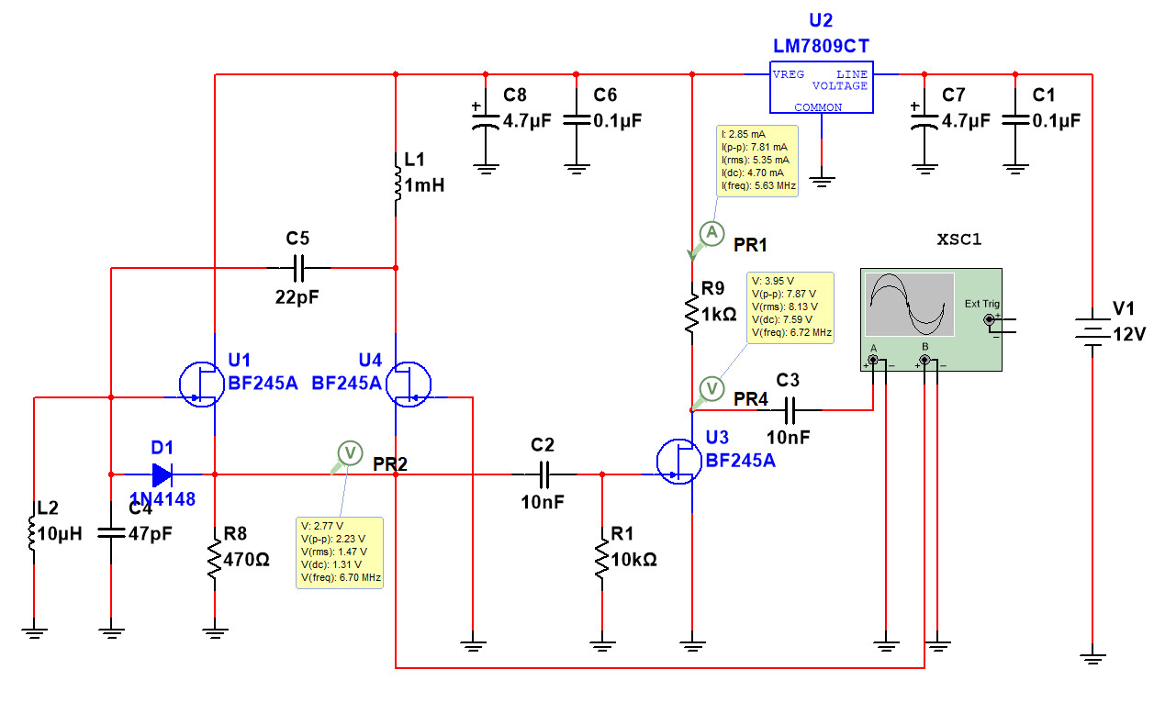

The version with a third FET amplifier gave me – on simulation – 7.87 Vpp at 6.7 MHz. Taking in consideration this is a simulation I expect in reality the signal to be a little lower, but now it is enough. The shape of the signal is still OK.

The VFO worked OK – in Multisim – in the 10 meter band, too. In order to make it usable for 455 KHz I had to increase the coupling capacitor between the first 2 FETs from 22 pF to 220 pF. In the resonator circuit I used a 1 mH coil in parallel with 360 pF. The reaction capacitor between the FETs and the shock also contributes at establishing the oscillation frequency, especially at low frequencies, when the inductance of the shock becomes comparable with the inductance of the tuned circuit.

Because this oscillator uses FET transistors and tuned circuits it is not recommended to try to do it on a breadboard. Oscillator with quartz crystals are OK on breadboard. The parasite capacitance of the breadboard would kill the fragile positive reaction of the 2 FETs. Bipolar transistors have more amplification and can eventually compensate loss of RF signal in the breadboard, but still attempting to make a variable frequency oscillator on a breadboard is a desperate cause. It remains to be done by soldering, first with all the components in the air, for testing its stability, and if the result is good I will practically use it in RF projects. To make the oscillation condition worse, the shock from the drain of the second FET radiates into the tuned oscillation coil, making a kind of negative reaction.
In an attempt to still do it on the breadboard (I know, I am stubborn – LOL), I replaced the shock from the schematics with a 10 KOhm resistor. Since the schematics of this 2 FET based oscillator is not mine I was looking to see if anybody else did this modification, too, and I found at least in the magazine “73 Amateur Radio – International Edition”, from September 1990, issue 360, page 48 the article “The Coil Tester”, by Michael A. Covington N4TMI.
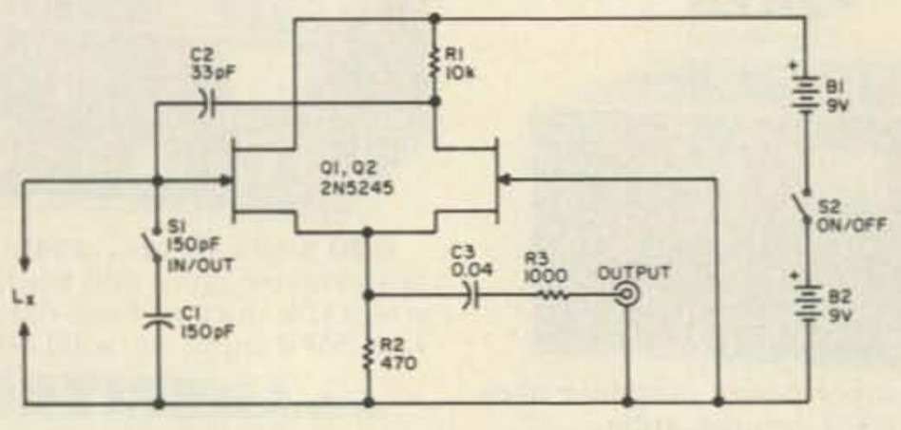
Michael A. Covington mentions “The FET version was first described by L.F. Heller in Wireless World . September 1969, page 409, but he used an RF choke instead of my resistor RI.” Oh, well, if we got the same solution, it must be the good solution. Here is the schematics I built on the breadboard:
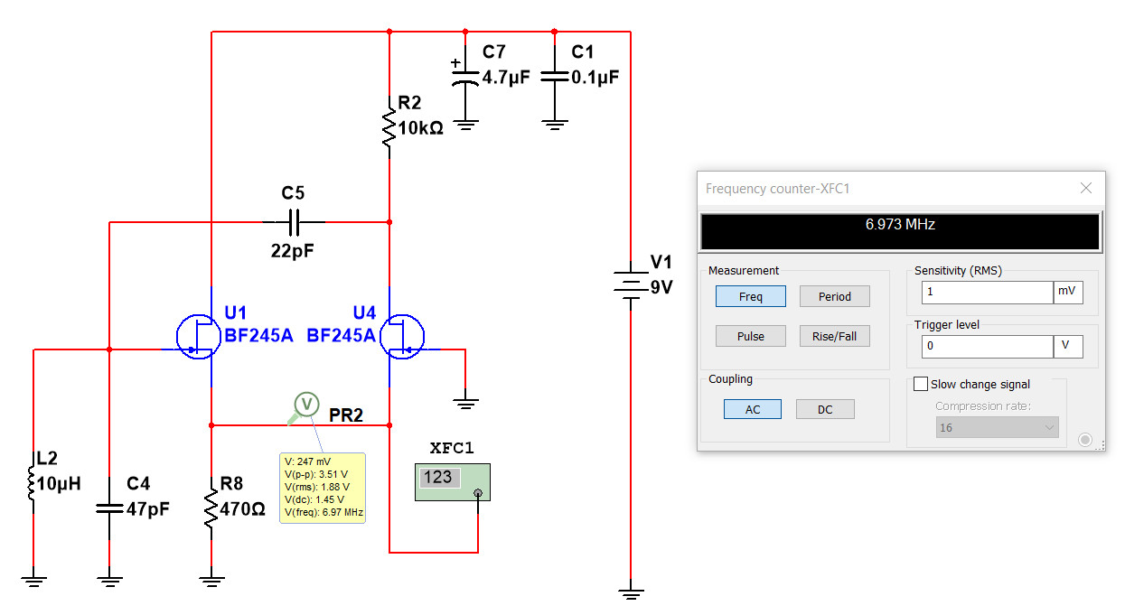
I measured L2 and C4, and they were very close to what it was written on them. Still, because of the tolerances and of the breadboard, I obtained 7.267 MHz instead of the theoretical 6.973 MHz.
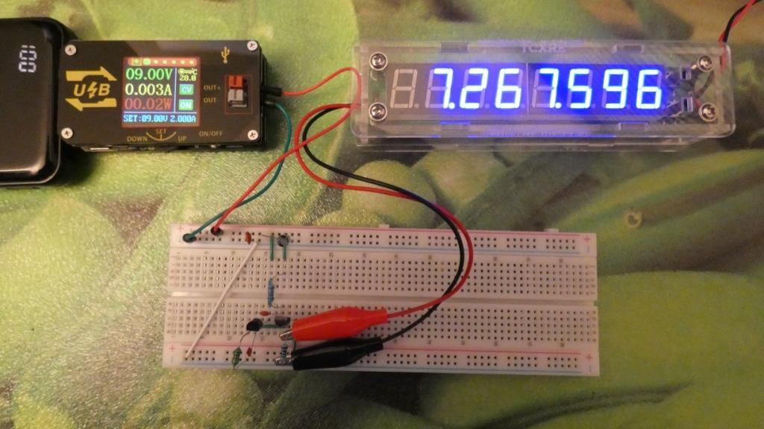
While the VFO was called by its author as going into the VHF my simulation started to struggle at 28 MHz. I would definitively use this oscillator up to 15 MHz, but not for higher frequencies.
In my breadboard test I did not put the thermal stability purpose diode 1N4148. Usually you see this diode in VFO from the gate of the oscillator put to the ground, which reduces the value of peak to peak oscillation voltage, but also makes the output level more constant in the interval of frequencies generated by the VFO. Other times you see this diode just between the gate and the source of the FET, which keeps the thermal stability purpose, without reducing the output oscillation voltage.

