Designing and Building
Audio Amplifiers.

Practical Tone Control Circuits.
I have lately found that there is a lot of interest in tone control circuits. It's beginning to seem as if 2/3 of the earth's surface is covered by water and the remaining 1/3 is covered with diagrams of tone controls. Although I have covered this topic under the heading of "Audio Amplifiers, How they Work" these circuits are not intended to be duplicated by the reader and there is virtually no information on how and where to insert them into an amplifier. This page will attempt to rectify that situation.

Where should tone controls be placed?
The answer to that depends on whether you are building or modifying an integrated amplifier or a preamp that is used with a separate power amplifier or monoblock power amplifiers. Also there is no one correct answer and there can be many variations on the theme and no one can definitely say that some of them are wrong. However, there are a few don'ts and they will be pointed out.

Volume and Balance Placement.
Although I have seen it done in commercial semiconductor amplifiers I don't recommend placing the volume and balance pots one after the other in a tube amplifier. Figure 1 below shows what I am talking about.
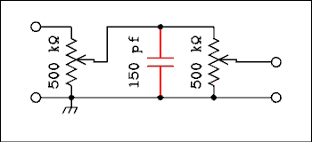
Figure 1 Diagram Showing Parasitic Capacitance Associated
With Volume and Balance Controls.
For a verbal description click here.
In my ill-informed youth I did connect a balance control pot right after a volume control. The loss of highs was obvious so I never did that again.
Due to its construction a pot has quite a lot of stray capacitance to ground. This is indicated by the capacitor in red in the diagram of Figure 1. The highest impedance is seen at the wiper when the control is set to half resistance.
Note. An audio taper pot has 10% resistance at half rotation. The half resistance point for such a pot is near the top, somewhere between the 3 o'clock and 4 o'clock positions.
When 10 k ohm pots are used, as in transistor amplifiers, this is not a problem. I measured a typical pot to have a capacitance to its case as 30 pf. Two pots together would have 60 pf and add another 90 pf for shielded wiring and tube capacitance and you have 150 pf. If two 500 k ohm pots are used the corner frequency is 10,600 cycles. Remember that is the -3 dB point. The response will be down by 1 dB at 5,500 cycles. That would give it a clearly audible and objectionable effect. There should always be at least a tube stage between the volume and balance controls.

Tone and Volume or Balance controls.
Can we place the tone and another level control pot, volume or balance, next to each other? Well, that depends. An active tone control, I'll define that later, by definition includes tube stages so it wouldn't matter. A passive tone control, no tubes, would be another story. Such a circuit with two pots and wiring to and from them is going to present a lot of capacitance, easily 150 pf. That lets out putting a passive tone control after a volume or balance control. What about placing volume or balance after a passive circuit? Lets take a look at that.
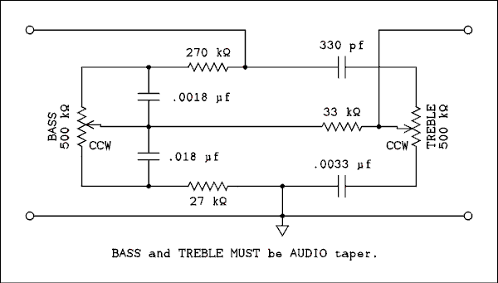
Figure 2 Passive Tone Control.
For a verbal description click here.
Whether we can place a pot with its own capacitance plus wiring capacitance after a passive tone control depends on the output impedance of the tone circuit. Because of the many capacitors in the circuit its output impedance is going to change a lot with frequency. But because high frequency roll-off is what we are concerned with, the high end is what we need to look at.
Consider the circuit of Figure 2. When the treble control is set flat, center of rotation it will present 50 k ohms between wiper and CCW end. So from the output to ground we have 50 k in the pot and a 0.0033 uf capacitor. The capacitor has 4.8 k ohms of reactance at 10,000 cycles so the resistance of 50 k ohms is mainly it.
Remember that an audio taper pot has 10% resistance at the center of rotation.
Over on the bass side there are two capacitors across the pot. The 0.018 uf across the bottom half of the pot will effectively short it out at 10,000 cycles. So the impedance to ground caused by the bass part of the circuit is 27 k ohms in series with 33 k ohms which adds up to 60 k ohms. The output impedance is the parallel combination of 60 k and 50 k which is 27.2727 k ohms, lets call it 27 k ohms. This resistance when combined with 150 pf gives a roll-off frequency of 39,300 cycles. The amplitude will be 1 dB down at 20,000 cycles. I have been deliberately pessimistic with the amount of capacitance so the effect should not be audible even to very young golden ears. Figure 3 is the graph of the frequency response with 50 picofarads of capacitance connected across the output. This is a simulation not the measured results from a real circuit.
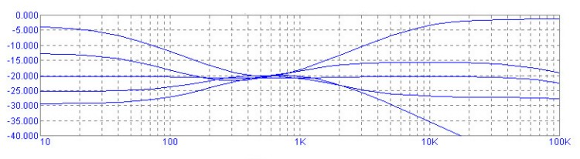
Figure 3 Frequency Response of Circuit in Figure 2.
For a verbal description click here.

Source Selector.
Obviously you don't want the tone control to effect just one source or want to have a separate tone control circuit for each source. Same goes for volume and balance. The source selector always comes first.
I can almost hear someone thinking "Hmmm. Separate tone, volume, and balance for each source. That could have some real advantages." It would, but you had better design your preamp with a big panel with lots of room for the controls. My preamp has 12 inputs. If you take away 2 for internal test signal generator and SCA decoder that still leaves 10.

Volume and Balance Controls.
Usual practice is to place the volume control right after the source selector although There is no reason not to do it differently. The usual rationalization is to be able to reduce the signal level right away to prevent overloading early stages. This design procedure was developed more than 50 years ago when input sources might not have been as well standardized as they are today. I can see definite advantages in putting the balance and tone controls ahead of the volume control. Lets look at a few block diagrams shown in Figure 4.
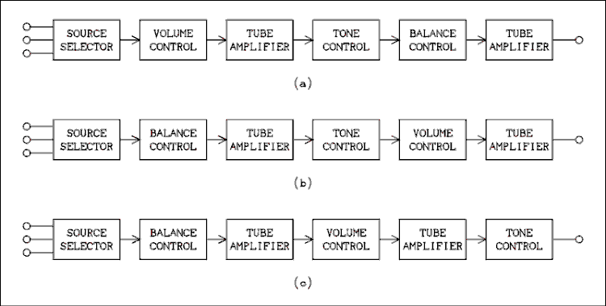
Figure 4 Three Alternative Block Diagrams of Preamp or Integrated Amplifier.
For a verbal description click here.
Block diagram (a) is the standard one and is in fact used in the Harmon Kardon A-300. The tube amplifier after the balance control is the first tube in the global feed back loop. This design could also be used in a stand-alone preamp because it ends with a tube amplifier which could include a cathode follower or two stage circuit with feedback to obtain a low output impedance.
Diagram (b) has the volume and balance controls interchanged. The balance control may have anywhere from 0 to 6 dB of attenuation depending on what balance circuit you plan to use. Look at balance circuits to find out more. These circuits are presented with values and enough information to make them usable in DIY projects. Any tubes that are between the balance and volume controls, including those in an active tone control, if used, must be designed so as not to overload at the highest signal level from any source.
Figure (c) could be used in an integrated amplifier in which the amplifier right after the tone control would most likely be the first stage in the global feedback loop. If it were used in a stand-alone preamp the tone control would have to be an active one or another tube stage would have to be added.
A preamp has to be connected to the power amplifier with shielded cables. These have a lot of capacitance to the tune of 30 or 40 pf per foot. A 3 foot cable could have 120 pf of capacitance and this is not highly pessimistic. To avoid having a corner frequency of less than 100 kc the output impedance would have to be less than 13 k ohms.

Passive Tone Control.
A passive tone control is defined as a network of resistors, some of them variable, and capacitors, that will function properly as a tone control in the absence of any amplifying device. Something else that distinguishes a passive tone control is the use of audio taper controls. This is very important. If you use linear controls you will find that the bass and treble are boosted and you will only get it to flat by setting the controls at 1/10 of their rotation. The cut will be in the remaining 10% of rotation.
The Baxandall tone control circuit above fits this definition. We have already established that it's output impedance is low enough to drive a somewhat capacitive load without audible roll-off. Its input impedance would be about 190 k ohms, worst possible case at the high end. Any tube would not have any difficulty driving this impedance.

Modified Harmon Kardon Circuit.
In the original HK amplifier the circuit diagram shows no resistor between the two wipers of the bass and treble pots. The circuitry is inside one of those packaged circuits but a test with an ohmmeter shows zero resistance between the two wipers. This is what is responsible for a rise in the low band around 200 cycles. I added the 33 k ohm resistor to bring it into compliance with what most people expect from this type of circuit. See Figure 2 above.
The passive tone control has very close to 20 dB of attenuation when set flat. The output voltage will be 1/10 of the input voltage. This is because resistors and capacitors alone can't provide any bass or treble boost. When boost is cranked in the bass or treble is attenuated less. The ideal case would be to precede this tone control with an amplifier that has exactly 20 dB of gain as shown in Figure 5 below.
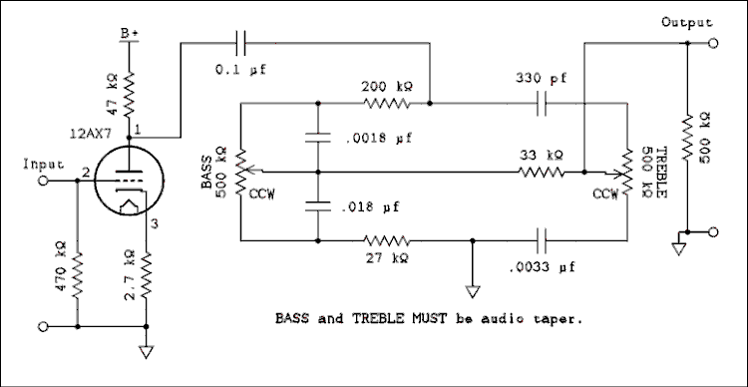
Figure 5 Passive Tone Control with Makeup Amplifier.
For a verbal description click here.

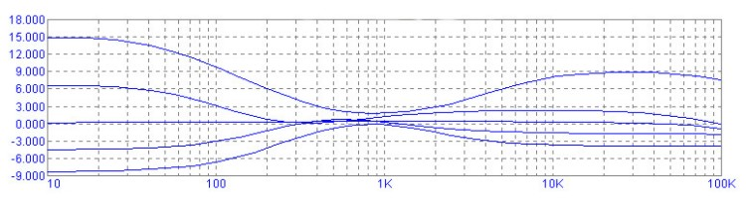
Figure 6 Frequency Response of Circuit of Figure 5.
For a verbal description click here.
The simulator steppes the bass and treble pots together in 10 dB steps. For example in a 500 k ohm audio taper pot, which most of the circuits use, the tone flat point is with the wiper at 50 k ohms which is 10% or 20 dB down from fully clockwise. This setting is always the center one, of the 5 curves on the graph. The one below flat is 15.8 k ohms and the bottom one is at zero. Above the flat curve the setting is for 158 k ohms and the top curve is fully clockwise, 500 k ohms.
The 12AX7 stage has a gain of 10 so the overall gain is unity or 0 dB. The treble range might not seem like much control but the ear is very sensitive to small changes in the treble band and I seldom set the control anywhere near its extreme. The only exception is when I play a 78 RPM record and I turn the treble all the way down. The 270 k ohm resistor became a 200 k because the tube stage has some resistance in its output. I know it should be a 220 k ohm but 200 k gives the flattest response when the bass is set to mid rotation. The simulation was run with 50 pf connected across the output.
The 500 k ohm load on the output is necessary to give a truly flat response at center of rotation. If you are sending the signal from the tone control to an amplifier stage, a 510 k ohm resistor should be placed from grid to ground. This is necessary, for the above reason, even though the Baxandall circuit contains a DC return. If you are placing a volume or balance control after the tone control it should be 500 k ohms and the wiper should go to the grid of a tube with no additional resistors to ground.

RCA Tube Manual Circuit.
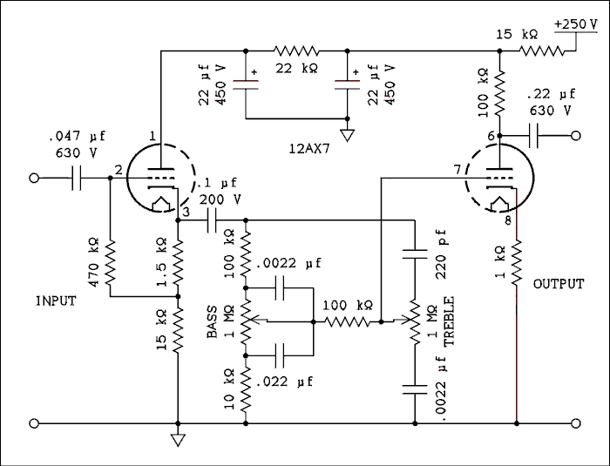
Figure 7 Passive Tone Control From RCA Tube Manual.
For a verbal description click here.

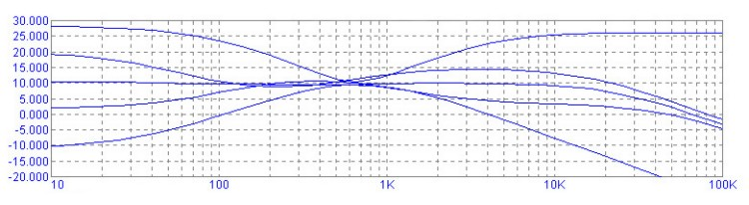
Figure 8 Frequency Response of Circuit of Figure 7. For a verbal description click here.
Figure 7 is also a passive circuit. The values are quite large and that gives it an increased sensitivity to capacitive loading. That is why it is preceded by and followed by a tube amplifier. Even with that, the natural stray capacitance causes the roll-off you see in the graph below.
If you are incorporating this circuit into an existing preamp you should modify the existing tube circuits rather than adding these amplifiers after and before existing stages. If you are designing from scratch the volume or balance control would go before the first amplifier and the other control after the output stage. As you can see even with the tube to isolate the tone control from capacitive loads the flat curve is rolled off to -3 dB at 20,000 cycles. Personally, I would never use this circuit in an audio project.

Not so many tubes.
If you would like a more robust control than the HK but not so many tubes as the RCA then you can combine them. Take the passive part from Figure 7 and drop it in place of the parts in Figure 5. Now divide all resistor values, pots too, by 2 and multiply all capacitor values by 2. The value closest to 50 k ohms is 51 k ohms. 5 k ohms, 5.1 k ohms. The capacitors should be 0.043 if you can get them. If not, 0.047 uf will have to do. This goes for all of the "22" capacitors. You will have a control with the large boosts and cuts of the RCA circuit but one that will drive the balance or volume control directly without an additional tube circuit.

Inserting a tone control between preamp and power amp.
Do you want a totally passive circuit to connect between an existing setup that is made up of a preamp and a stereo power amplifier or two monoblock amplifiers? Someone who wants to do this likely doesn't want any tubes in the tone control, just a little box with 2 or 4 knobs on it to control the tone.
Many power amplifiers have lots of sensitivity. One I have heard of needs only 0.15 volts to drive it to full power. However, even if yours is specified to require 1 volt for full power you still will have plenty of gain left over. Who plays their amplifiers at full power? Kids in cars do but at home the adults I know have higher regard for the health of their inner ears to do that.
Most preamps are designed very conservatively to drive a long shielded cable. To give it that capability the output impedance is quite low. So it can drive a relatively low impedance circuit. Knowing that we are going to connect the tone control box to the power amp with shielded cable we must give the tone control circuit a low enough impedance so the highs won't be rolled off by the cable capacitance. Figure 9 is one channel of a circuit. The other channel looks exactly like it. The pots may be ganged or separate according to builders taste.
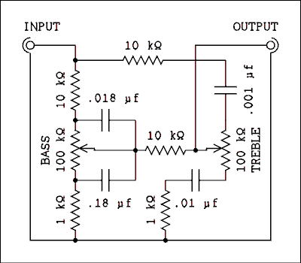
Figure 9 Passive Tone Control for Insertion
Between Preamp and Power Amp.
For a verbal description click here.

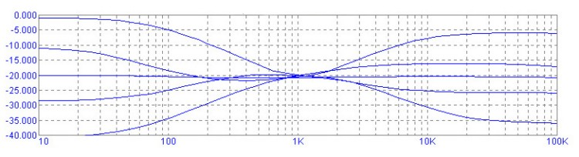

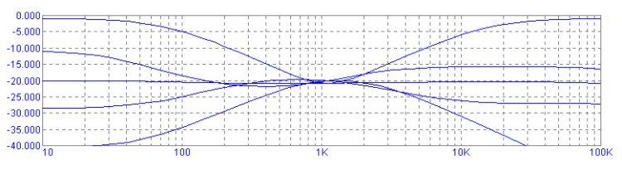
Figure 10 Top, Frequency Response of Circuit as Shown. Bottom,
Frequency Response Without Fixed Resistors in Treble Arm.
For a verbal description click here.
You will notice the addition of two resistors. These will ensure that the treble cut will shelve instead of falling out of site. The top graph in Figure 10 was made with the resistors in place and the lower one with them set to zero ohms in the simulation. It may be argued that it really doesn't make any difference since it all happens above 15 kc. Some people might want to bring the break points of the treble control down to a lower frequency. If this is done, shelving could become important. To lower the treble frequencies increase the values of the capacitors above and below the treble pot. Remember to keep them in a 10 to 1 ratio.
If you find that the bass and treble boost and cut are indeed more than you need you could increase the input impedance by increasing the four fixed resistors that are above and below the bass pot and above and below the treble pot. Make the 10 k a 22 k and the 1 k a 2.2 k ohm. This will reduce the bass boost and cut by 6 dB but it will raise the input impedance to 24 k ohms.
At low frequencies where the value of the output coupling capacitor may become important the tone control will present a higher impedance load because the reactance of the two capacitors across the bass control has increased. The 0.022 uf capacitor has a reactance of 145 k ohms at 50 cycles. The impedance will decrease some as the bass is boosted.
The simulation was run with a capacitive load of 105 pf which would be the approximate capacitance of a 3 foot shielded cable.

Active Tone Controls.
Now we are up to active tone controls. They are defined as needing an amplifier to work properly. They also use linear controls. The advantage of linear controls is they always have half resistance at half rotation. Some audio taper controls do not have 10% resistance at half rotation. With active controls it is easier to be sure that setting the controls to center of rotation will give tone flat. It is still the basic Baxandall circuit but it is in the feedback loop of an amplifier. Transistor designers jumped on this one early on because gain is so easy to come by in a small space as compared to tubes. It is doable with tubes but might require one extra 12AX7 per channel as compared to passive circuits. Many people might say that the improved symmetry of response curves is worth it. I would be inclined to agree.

The Brimar Circuit.
Brimar was the name of a tube manufacturer in England who came up with the circuit shown in Figure 11.
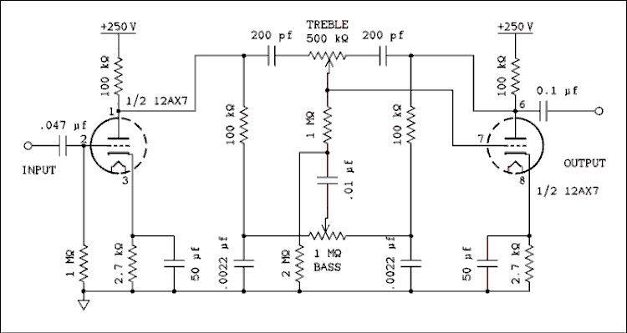
Figure 11 Brimar Tone Control Circuit.
For a verbal description click here.

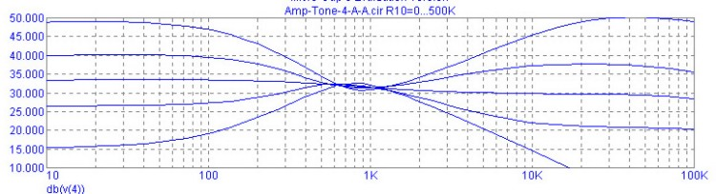
Figure 12 Frequency Response Showing a Flaw.
For a verbal description click here.
This circuit looks quite elegant on paper, or computer screen, but the frequency response shows a real problem. Look at the flat gain in the bass portion and compare it with the same curve in the treble region. I imagine this would give the amplifier a rather dim sound, the opposite of bright. The tube on the right has a lot of feedback around it but the one on the left is operating completely open loop and at full gain with a bypassed cathode resistor. The output resistance of this stage is the 100 k ohm load in parallel with the plate resistance of the tube (12AX7) which is 80 k ohms. That works out to 44 k ohms. The graph in Figure 15 below shows how the impedance of a similar circuit varies with frequency. This problem could be cured by adding a cathode follower to each amplifier stage.
In spite of its other shortcomings you will note a much improved symmetry of the frequency response over the open-loop Baxandall tone control. This makes for a much smoother cut and boost as well as identical spectra for both.
The circuit has 33 dB of gain at tone flat and 100 cycles. Removing the cathode bypass capacitor only lowers this figure to 25 dB. That's still a lot of gain to stick into the middle of a preamp. I have never owned a commercial preamp but my design approach would be to give it 10 dB of gain with the volume control set to maximum. The argument being, the output stage should not be driven into clipping even at maximum volume and tone setting. Most sources deliver about 0.7 volts RMS which is about 2 volts peak to peak. 10 dB will increase this to 6.3 volts peak to peak. Granted that's not much for a tube amplifier but if the owner decides to crank in full bass boost at 15 dB more we are up to 35 volts P-P. That's certainly at a level which could increase distortion if not taking it to the point of clipping. So dropping this control into the middle of a preamp would increase the output to a whopping 623 volts peak to peak. If you are still awake you will remember that I put in an initial gain of 10 dB. If we take that out and just have the tone control with the cathode bypass removed, 25 dB of gain from the starting point of 2 volts P-P gives us 36 volts and then the 15 dB of bass boost puts the overall gain at 40 dB which will give 200 volts P-P from our original 2 volts P-P. No matter how you slice it, it seems to be too much gain. A figure of 10 dB gain plus 15 dB of bass boost will give 36 volts P-P from our original 2 v P-P. So I think I'll stick to my 10 dB overall gain figure.

Putting the Baxandall Inside a Feedback Loop.
The curves of the open loop Baxandall circuit may seem a little less than perfect. I would be the first to grant that it probably would be impossible to hear the difference. However, I am somewhat of a perfectionist so it would be nice if a circuit could be developed that behaved better than the passive circuits above. It seems that if we put the passive circuit inside of the feedback loop of an amplifier it will give curves that look much better.

The Principle of an Inverting Amplifier.
To understand how an active tone control works we must digress a little to study inverting amplifiers. The inverting amplifier has several unique features but the one that is important to us is the ability to employ feedback to set it to less than unity gain. The noninverting amplifier can be set to unity by strapping the output to the inverting input. The gain can't be set any lower than that. The inverting amplifier, in Figure 13 (a) below, does not have this limitation.
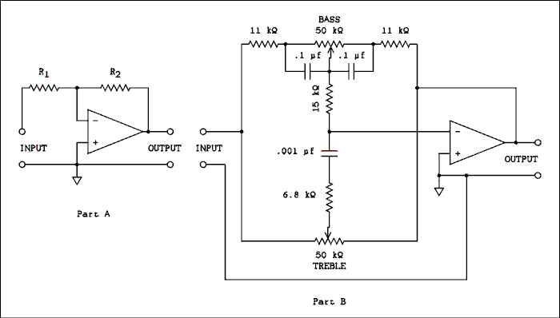
Figure 13 (a) Showing How Feedback Sets Gain.
(b) Showing Tone Control in Feedback Loop.
For a verbal description click here.
In the circuit of Figure 13 (a) , a generalized amplifier has feedback applied from output to inverting input through R₂. The input signal is applied through R₁. If the gain of the amplifier is large the voltage from the inverting input to ground will be small. That means the currents through R₁ and R₂ are set mainly by the magnitude of the input and output voltages. If the input impedance of the amplifier is large the current flowing through the input terminal will be very small. Thus we can say that the current in R₁ is the same as the current in R₂. We can write the equations,
V_{IN} = I₁ x R₁ and V_{OUT} = I₂ x R₂
But,
I₁ = I₂
Because the currents in R₁ and R₂ are equal and in the same direction and V_{IN} is on the left end of R₁ and V_{OUT} is on the right end of R₂ the input and output voltages have to be of opposite signs.
Lets try some simple logic on that one. Now, we must be sure to say exactly what we mean and mean exactly what we say. In part A of Figure 13 above, the term, input refers to the left end of R₁. Output refers to the right end of R₂ which is also the amplifier output. Inverting input refers to the point where R₁ and R₂ connect to the amplifier. Remember that the voltage at the inverting input of the amplifier is very small. Lets call it zero for the sake of argument. If you place a positive voltage on the input the only way to get zero at the inverting input is for the output to be negative. The inverting input is a tube grid so it is an open circuit. You can't have both ends of the resistor string be negative and have the middle be zero. They must always be opposites. Now, if the input signal is AC the output will be AC of the opposite phase. And that, Virginia, is why its called an inverting amplifier.
We are going to solve the two equations above for I, since they are equal, and set them equal to each other. But because of the sign difference between input and output we have to sneak in a minus sign.
V_{IN} / R₁ = -V_{OUT} / R₂
Rearranging gives,
V_{OUT} / V_{IN} = -R₂ / R₁
Of course V_{OUT} / V_{IN} is the gain. If R₂ is larger than R₁ the gain will be greater than unity. If R₂ is less than R₁ the gain will be less than unity.
One more little fact about an inverting amplifier is that the inverting input acts like a low impedance point. If the gain of the amplifier is very high, say one million, the input will act like a dead short to ground. The reason for this is, what ever the input voltage does the output voltage will be adjusted to the opposite sign and the necessary magnitude to keep the inverting input at zero. There is current flowing but no, or very little, voltage and that spells low impedance. In practical operational amplifiers the inverting input point, or summing node, is often referred to as a virtual ground. For more information on the subject of feedback amplifiers refer to Chapters 5 and 6 of my textbook Electronics for Physicists. The book is on another web site so use your back button to return here.
Now look at the schematic of Figure 13 (b) above, in which the Baxandall circuit has taken the place of R₁ and R₂. Strange as it may seem there is virtually no current flowing in the 15 k ohm resistor or the 6.8 k ohm resistor.* Looking back at part A, the current due to signal is flowing through R₁ and R₂. There is essentially no current flowing in the vertical line connecting the junction of the two resistors to the inverting input. A resistor could be placed in this line with no measurable effect on the performance of the amplifier. The one restriction would be that the added resistor must be much less than the input impedance of the amplifier. In part B, the input resistance of the amplifier is much greater than the 15 k ohm resistor. At frequencies where the reactance of the 0.001 uf capacitor becomes large the treble control is no longer having any effect so this is of no consequence.
* This statement is true only if the two controls are set to the same point. If there is a difference the circuit becomes more difficult to analyze and we will leave such analysis for another time and place when and where everyone understands how to use the j operator.
The wipers of the pots are at zero potential so if they are set at center, the connection points on the left and right are at the same potential and opposite phase. This is equivalent to R₁ = R₂ in part A. The gain is unity for all frequencies. If the wipers are moved to the left this is equivalent to R₁ growing smaller and R₂ growing larger. This will increase the gain but only for lows and highs. The mid range, around 1,000 cycles will be little effected. Moving the wipers to the right of center will cause the gain to be less than unity and the highs and lows will be cut.
If the bass control is moved to the left while the treble control is left at the center, the unbalance will drive current through the 15 k ohm resistor at low frequencies. The effect will be that of decreasing R₁ and increasing R₂. The gain will be increased for low frequencies. At mid and high frequencies the two 0.1 uf capacitors will keep the circuit balanced, R₁ = R₂, and the gain for these frequencies will remain at unity.
When the bass pot is returned to center and the treble pot is moved to the left the wiper becomes unbalanced for all frequencies but only the highs are coupled to the inverting input through the 0.001 uf capacitor. A circuit with two capacitors, one on each side of the treble pot performs better and is easier to understand. I have not run a simulation on the circuit in part B so I can't say how well it performs. It could be used with op amps or transistorized gain blocks but it's impedance is too low to be used with tubes. Well, maybe with cathode followers.

A Tone Control You Can Love.
Figure 14 shows the tone control that I think has the best compromise between performance and tube count. Yes Virginia, everything is a compromise. It uses only two triodes per channel, one 12AX7 or your choice of other hi mu triodes, and it has a nice symmetrical looking frequency response curve. Its gain when set to flat is about -1 dB which is close enough to unity to not cause overload problems in a preamp or integrated amplifier. You could transplant the tube stages from Figure 18 below if inclined. The performance would be slightly improved.
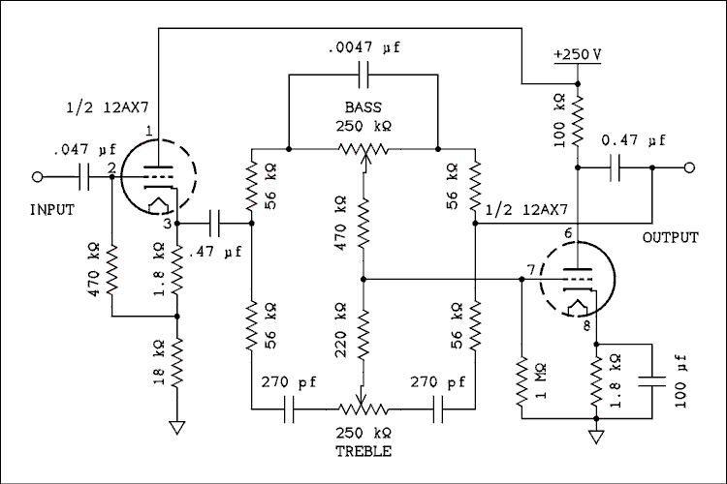
Figure 14 Practical Tone Circuit Using One 12AX7 Per Channel.
For a verbal description click here.
The pots are linear taper and the center of rotation is tone flat. Moving the wipers to the right on the diagram is cut, which would be the counter clockwise position, and to the left is boost, the clockwise end of the control. All resistors are 1/4 watt although you may use 1/2 watt if you prefer. The 100 k ohm resistor from pin 6 of the 12AX7 should be a 1/2 watt in any case. The 0.47 uf capacitor on the left may have a voltage rating as low as 200 volts but the one on the right should be a 630 volt. The voltage rating of the 0.047 uf depends on what is connected to the input of the circuit. If it is the plate of a tube the voltage should be 630 volt. If the wiper of a pot a 200 volt would be fine. The three capacitors in the tone circuit don't need to be anymore than 50 volts although there is no harm in going much higher if they are all you can get.
Unlike the passive circuit this one uses a single capacitor across the bass pot instead of two from each end to wiper. If this were to be done in a passive circuit setting of the bass control would alter the amount of treble boost or cut. The virtual ground of the amplifier grid effectively isolates the bass and treble circuits and the interaction amounts to about 1/100 of a dB.
This was not done to save capacitors. Connecting two capacitors from wiper to each end causes the resistance in parallel with the capacitor to change as the bass pot is turned. This causes the corner frequency of the bass boost and cut to change depending on the setting of the pot. This effect is clearly visible in Figure 10. Figure 15 looks much better as the breakpoints on the bass curves remain constant regardless of the setting of the control.
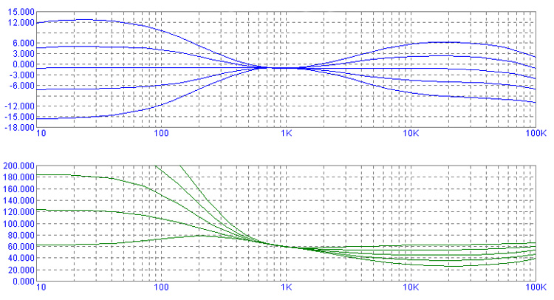
Figure 15 Graph Showing Frequency Response, and Drive Impedance of Circuit of Figure 14.
For a verbal description click here.
The graph at the bottom in green is k ohms of input impedance of the tone circuit. The measurement was made by inserting a current controlled voltage source in series with the 0.47 uf capacitor on the left. The bottom line is full boost, the next one up is half boost and the highest one to be completely on the graph is flat. Now you can see the reason for the gain variation in the Brimar circuit above. With an impedance of 80 k ohms at 100 cycles and 45 k ohms at 10 kc it's no wonder why a cathode follower is required to drive the circuit. The amplifier on the right would have the same trouble if it didn't have so much feedback around it. It's open-loop gain does change but not enough to cause any significant problems.

Three Band Tone Control? Maybe.
The circuit of Figure 16 was sent to me by a gentleman who asked me to evaluate it for him. It turns out to be useless as a tone control but I am posting it for what it has the potential to become, which is a 10 band graphic equalizer using tubes. Each channel would require 6 and 1/2 12AX7s which may or may not look feasible to you.
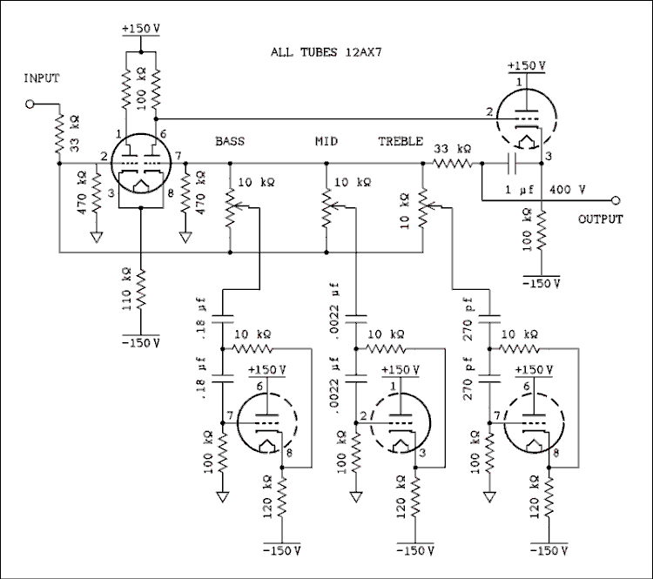
Figure 16 Three Band Tone Control? Or Unfinished 10 Band Equalizer?
For a verbal description click here.
Moving the wipers to the bottom in the diagram gives full cut and to the top full boost. The 110 k ohm and 120 k ohm resistors should definitely be 1 watt. The two 100 k ohm resistors in the plate of one of the 12AX7s should be 1/2 watt and all other resistors may be as small as 1/4 watt. All capacitors should be at least 200 volt. The frequency determining capacitors aren't exposed to any appreciable voltage during operation but if B- comes up before the tube cathodes are hot, these capacitors would feel 150 volts.
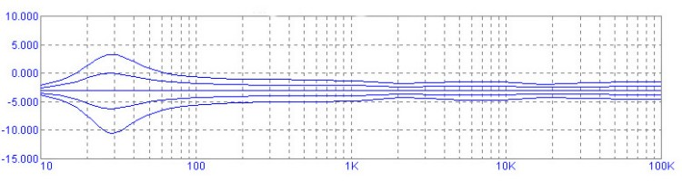

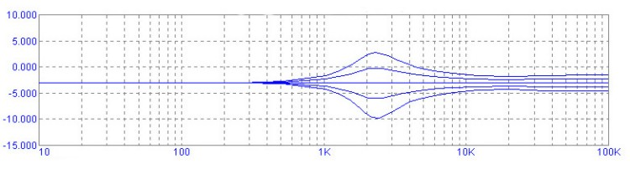

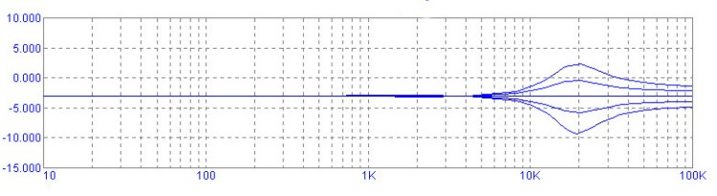

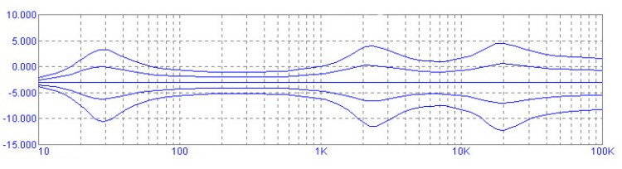
Figure 17 Frequency Response of Each Band and Then All Three.
For a verbal description click here.
The first graph shows the effect of setting the low band pot to full cut, half cut, flat, half boost, and full boost. The other two are not changed but left set flat. The second graph shows the effect of the mid band pot with all others held constant and the third shows the effect of the high band pot. The fourth shows all three being changed simultaneously. The equation for the frequency is,
f = 1 / (6 Pi R C)
Where R is the 10 k ohm resistor and C is the value of the capacitors connected to it. The values of capacitors for a 10 band EQ would be as listed below.
Frequency (cycles) | Capacitor  Standard Value | Capacitor  Calculated
31.5 | 0.18 uf | 0.168 uf
63 | 0.082 uf | 0.0842 uf
125 | 0.039 uf | 0.0424 uf
250 | 0.022 uf | 0.0212 uf
500 | 0.01 uf | 0.0106 uf
1,000 | 0.0056 uf | 0.00530 uf
2,000 | 0.0027 uf | 0.00265 uf
4,000 | 0.0012 uf | 0.00133 uf
8,000 | 680 pf | 663 pf
16,000 | 330 pf | 332 pf

A 3 Band Tone Control You Can Love.
The circuit shown in Figure 18 originally came from a book of op amp circuits. I increased the impedance level to make it suitable for tubes and did quite a lot of reengineering on it. The pin numbers on the left hand triode are for half of a 12AU7. If you elect to use a 6C4 the pin numbers will have to be looked up on line or in a tube manual. If you would like to use one less triode per channel you could transplant the amplifiers from Figure 14 above. You might notice a slight reduction in performance. All resistors are 1/4 watt unless otherwise noted. All the capacitors that are associated with tubes are 200 volt, All others can be as low as 50 volt if you can find them that low. The two 1 uf caps and the 0.047 uf cap are the only ones that will have any DC voltage across them. The 0.047 uf cap may need to be a 630 volt if there is another tube stage connected to the input.
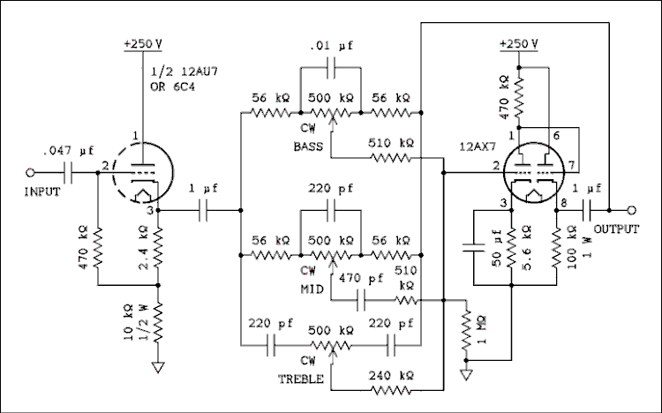
Figure 18 Practical 3 Band Tone Control.
For a verbal description click here.

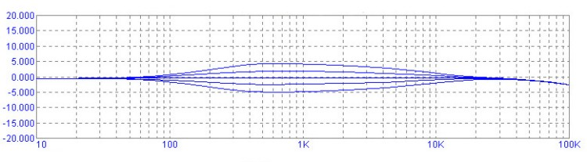

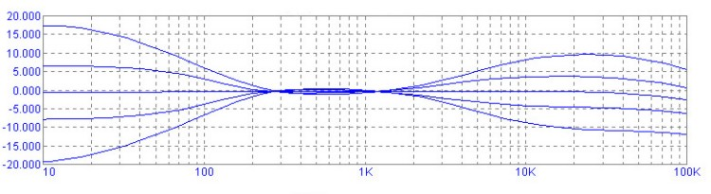

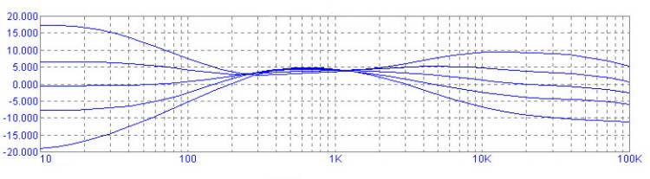

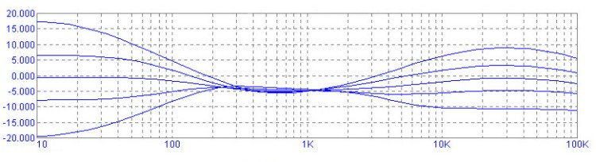
Figure 19 Frequency Response of 3 Band Circuit with Controls Set In Various Combinations.
For a verbal description click here.
The first of the four graphs above shows the mid band control being adjusted while the bass and treble are left set flat. The second shows the bass and treble being adjusted while the mid band is left flat. The third shows the bass and treble being adjusted while the mid band is set at full boost. The fourth shows the bass and treble being adjusted while the mid band is at full cut. The mid band may not seem to be having much effect but the ear is so sensitive in this frequency range that a little goes a long way. At some time in the past I owned a receiver that had a three band tone control of this type. A friend who owned the same model plotted the frequency response curves of the tone control and they looked very much like these. The mid band control had a clearly audible effect.

Alternative Amplifier Circuit.
As stated above the amplifier circuits can be switched around from one control to another depending on how much of a perfectionist you are. Figure 20 shows an amplifier circuit contributed by Mike from the Fun with Tubes email list.
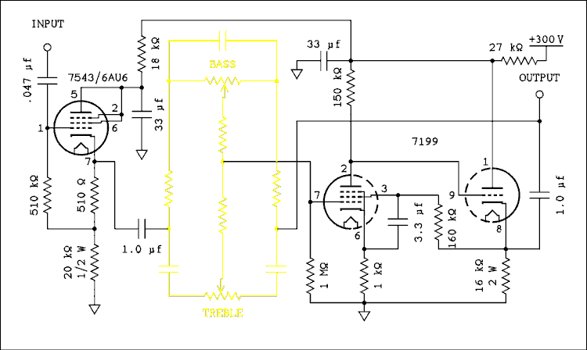
Figure 20 Another Set of Amplifiers for Figures 14 and 18.
For a verbal description click here.
The output stage is borrowed from the phase inverter circuit used in a series of amplifiers found in RCA tube manual RC-28. This gives higher gain than a triode along with low output impedance. The cathode follower keeps the tone circuit from lowering the gain of the amplifier unlike the one used in Figure 14. Using a pentode as the input cathode follower will give a lower output impedance because the tube has a higher transconductance than a triode.
Well, that's about it. I hope this gives you something new to have fun with.

