Convert BC-221 to Solid State
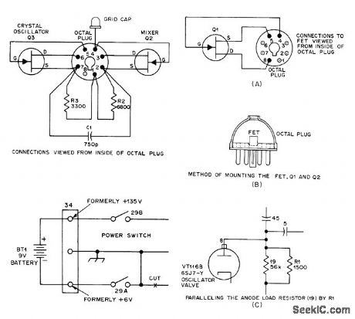
TRANSISTORS FOR BC-221-Old BC-221 frequency meter can be modernized by replacing its three now-scarce tubes with four 2N3819 Nchannel JFETs and changing supply to single 9 V battery. VT167 (6K8) mixer-oscillator is replaced by two JFETs with R2, R3, and 01 mounted inside octal plug. Resistance values may need some adjustment. Cut and insulate original leads to pins 2, 4, and 7, and connect top-cap clip of mixer tube to pin 4. VT116-B (6SJ7-Y) tube used for VFO is replaced by single 2N3819 connected as for Q1.Place 4K across 15K Add RI in parallel with plate load resistor; value depends on par-ticular FET used, and can range from 1 to 6800 ohms (1500 is typical). VT116 (6SJ7) beat-fre-quency amplifier is replaced by 2N3819 mounted same as for al. Place 4K across 15K load resistor of VT116-B and replace 300-ohm cathode resistor with one giving 1-mA source current (typically 1K to 3.3K). Total current drain is about 3 mA. Try 3-10 pF capacitor between gate and drain of 03 if circuit does not oscil-Iate.-R. S. N. Rau, Solid-State BC-221 Fre-quency Meter, 0ST, Feb. 1977, p 35-36.

