HOT IRON #123, January 1st, 2024
THE JOURNAL OF THE CONSTRUCTOR’S CLUB

Technical Editor: Please send technical questions to Peter, G6NGR
Content and Distribution: Send ideas for content or subscriptions to Frank, W4NPN
Hot Iron Library of issues (.pdf downloads) Hot Iron Searchable Compilation-all issues
Hot Iron Index; subjects and issues Hot Iron Technical Library

Our wonderful hobby includes participants with a great deal of electronic knowledge as well as those just beginning their journey. Our quarterly newsletter tries to publish a little something for each!

Hot Iron’s Reference Data document is a library of tables and other information needed when working with electronics. Rather than repeating these many pages in every Hot Iron edition, we have elected to put them in a separate document which you can access here.
========================================================================
Hot Iron is a quarterly newsletter (next quarterly issue is at the end of February) but we thought we would publish this short New Year’s issue to celebrate the arrival of 2024.

* A recent discussion about SWR and SWR Meter functions was recently overheard . It was apparent that many do not understand what the SWR meter is telling us. KL7AJ’s article, “SWR Meters Make You Stupid,” published on eHam, explains it all in a lighthearted way.

* SWR – What’s it all About – Who Cares is another article that explains what happens to the transmitters power, as it passes through a tuner, balun and feedline and how it gets radiated.

* We hope that at least some of our readers do occasional building of their own transmitting/receiving equipment or shop test equipment. If you build a tube-type transmitter, you will likely need a full break-in T/R switch, used to prevent frying the RF amplifier input stage of your tube-type receiver. Read about these and find several designs here.

* “What is Ham Radio, my barista asked” is an article found in the Random Wire newsletter. It was written by Tom Salzer (KJ7T) and illustrates the need for a concise definition of our hobby that can be provided to a non-ham who wants to know.

* Dave, N2MMX posted on Facebook about a unique piece of software he has written, which displays a dozen “tiles” of interest to hams. Click this link to open the display – it’s really something! And here’s a link to the article posted to The Random Wire. The display looks like this:

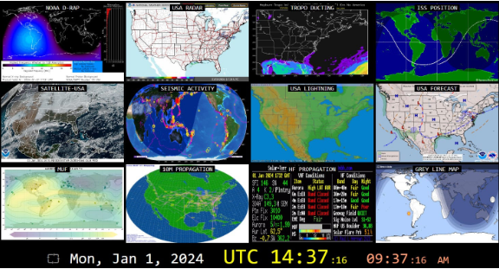

* Amateur Radio Weekly’s edition #313 contains several articles of particular interest, including:
- A link to the Practical Antennas website, which contains a wealth of antenna information.
- A 200 ft Antenna up Zero feet.
- Amateur Radio License Map. Enter your zip code and find all the amateurs near you – this was a real surprise to Frank. There are more than 750,000 in the USA and about 3 million world-wide but the map is an eye-opener.
- There’s more so have a look! Issue #312 has a link to the Olivia Digital Mode for HF.
* Zero Retries newsletter #0131 has a lot of information you won’t find elsewhere, including a Raspberry Pi link.

* It’s fun to scroll through the back issues of Ham Radio magazine, provided by World Radio History. Ham Radio was published from 1968 to 1990 and there is a lot of theory, projects and ideas in these issues. It’s also interesting to see how our hobby changed from the 60’s to the 90’s. These are worth a read during these cold winter months. It’s a real rabbit hole!
* Introduction to HF Packeteering in the Modern Age. This informative article by N6CTA provides everything one needs to know about the subject. The link was found on the latest issue of Amateur Radio Weekly.

* Did you know? Based on current and future sales of microchips built by Nvidia
specifically for AI, global power usage for AI systems could ratchet up to 15 gigawatts of continuous demand. That’s about the power consumption of the entire Netherlands, and would require all the output of about 15 average-size nuclear power plants. Wow.

* The RF Soup we live in. We have been bathed in a field of varying frequencies and powers for nearly 100 years now, beginning with early electrical distribution systems, moving on to radio frequencies, and now to all manner of solid state and cellular devices. No harm has been definitively proven but there is certainly some controversy and lots of opinions about the matter. An interesting chart from Hot Iron #72 illustrated the sources of our radiation environment:

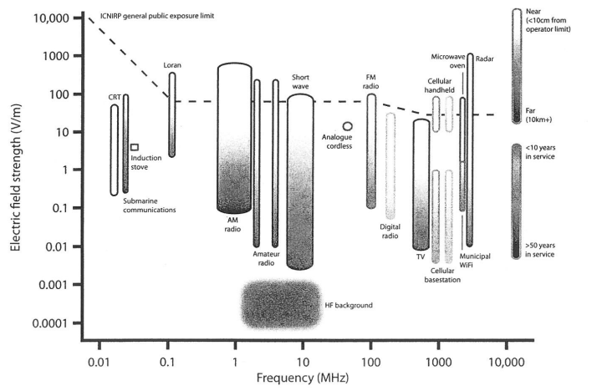

* Light Bulb Dummy Loads have been used for perhaps 100 years or so by ham operators. This Ham Radio article explains how to make them more useful and better matched to modern transmitters. When the publication opens, scroll down to page 74.
* Joe Carr, K4IPV (SK), wrote an extensive article, beginning on page 71 of the July, 1977 Ham Radio magazine, describing the many measurement devices that can be used with antenna installations. Although close to 50 years old, the techniques haven’t changed and designs for simple measurement instruments are given. You can find a link to that article here.
The following instruments are described:
RF Ammeters
RF Voltmeters
Wheatstone Bridge
The Noise Bridge
Antenna Impedance Meters
SWR Bridges
RF Wattmeters
While you are thinking about antennas, check out the antenna section of this website.

Hot Iron’s list of other Ham-related Newsletters and some specialty clubs follows (please let Frank know of non-sales NL’s not listed here):
* The Zero Retries newsletter always contains articles of interest. Click the link!
* Amateur Radio Weekly, curated by K4HCK, is more news-oriented than construction-oriented, but every issue seems to have at least one construction-oriented project. You can link to the issues archive here. It’s free.

* The Random Wire is another ham-related website that Tom Salzer, KJ7T, operates. It addresses many facets of amateur radio, from high-tech to some construction techniques and seems to have something to everyone.

* Here’s a link to the ARRL newsletter, which has many pages of news of interest to us hams.

* DxZone publishes a substantial list of amateur radio newsletters. Have a look!

* The QRZ Forum contains news, technical information, discussions and equipment evaluations; there is much to read here!
* This DX Engineering website has 31 pages of news and general information about ham radio. Many antenna and feedline articles are included.

* QRP ARCI is a club for low power enthusiasts worldwide.

* The American QRP Club is for builders, experimenters, and low power enthusiasts.

* VK3YE’s QRP website is not a club but it provides a lot of information about QRP operations.
* The DXZONE provides a list of QRP websites
* Check out the various sections of www.w4npn.net, the website where the Hot Iron newsletters are hosted. There is much more there! Another rabbit hole.

Future Quarterly Newsletter Content – some subjects we are considering; what are your suggestions:

Crystals and Crystal Oscillators, a VFO issue, Regenerative Receiver designs, Classic Xmtr designs, Power Supplies. What interests you? Let us know!

Disclaimer: We have no ties with any commercial company mentioned in Hot Iron editions or on the w4npn.net website.
Please share Hot Iron with your friends and radio clubs, etc.! There is no cost and we do not share the address list with any other organization.

