HOT IRON #128: February, 2025
THE JOURNAL OF THE CONSTRUCTOR’S CLUB

Technical Editor: Please send technical questions and suggestions to Peter, G6NGR
Content and Distribution: Send ideas for content or subscriptions to Frank, W4NPN
Hot Iron Library of issues (.pdf downloads) Hot Iron Searchable Compilation-all issues
Hot Iron Index; subjects and issues Hot Iron Technical Library
================================================
Our wonderful hobby includes participants with a great deal of electronic knowledge as well as those just beginning their journey. Some prefer digital modes and projects, others prefer analog projects and devices that glow in the dark. Our quarterly newsletter tries to publish a little something for each! Since it’s a quarterly publication, it tends to look back at ideas and articles published historically.
* If you haven’t visited the Internet Archive, do so soon! It contains a huge DLARC library – just enter DLARC in the website’s search box. Amateur Radio Weekly #365 contains a link to Zero Retries #184 where Kay Savetz, K6KJN, has an informative write-up that lists some of the additions made to the Internet Archive DLARC library. Check it out!
* The DLARC library contains the entire run of 73 magazine issues – click the link to see these – they are perfect reading for a cold winter’s night. Try this article about “Rotary Wabbit Ears,” published in 1960. Might be a good idea for a small rotary dipole “beam”.
* K4HCK reminds us that “there are other magazines in another archive - https://www.worldradiohistory.com/index.htm that features magazines such Popular Electronics, Radio & Electronics, etc.” We’ve mentioned this before but it’s a good idea to repeat it from time to time.
* The January – February 2025 issue of The Communicator is full of articles – click the link to read it online!
* Simple Conversational Amateur Message Protocol (SCAMP) is a weak signal digital mode developed by Dr. Daniel Marks (KW4TI). Originally integrated with the RFBitBanger transceiver, SCAMP is now available for broader use through the Fldigi software suite. This information comes to us via Amateur Radio Weekly #363.
* The same issue of Amateur Radio Weekly contains a good video about finding the source of HF noise caused by something(s) in your home.
* A library of ARRL handbooks and other ARRL publications, containing handbooks from 1926-1984, and many other publications can be found at the above link. The Antenna Handbooks and the nine volumes of “Hints and Kinks” should contain a lot of nice-to-know information. Scrolling through the old “Hints and Kinks” takes us ‘way back in time.
* Amateur Radio Booklet-2024 contains a wealth of operating information and is available here, or from the Amateur Radio Weekly newsletter #362. This is written and published by F4JJD who generously makes it available to all of us.
* A recently overheard multi-party discussion indicated a great lack of understanding of Standing Wave Ratios, transmission lines and tuners. Perhaps this page will help clear up some questions.
* Back to basics: Remember this so-useful Ohm’s Law Pie Chart?
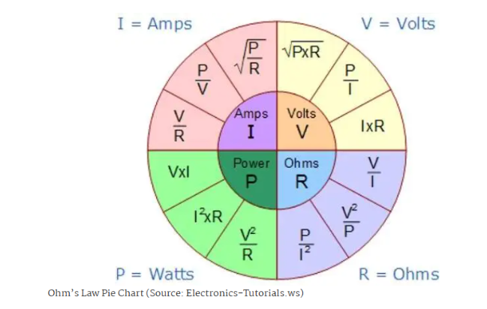

Here is an extensive discussion about Ohm’s Law and the relationships it can calculate.

PROJECTS:
* Old, unobtanium or costly valves (tubes) deserve TLC to preserve their heaters. Here’s an article by Tim Walford on just that subject:
Heater delay for old valves
By Tim Walford G3PCJ - Nov 2024

The need for this gadget was triggered by my son insisting that I get my old wartime WS17 set working properly. It is a semi-portable valved AM transmitter intended for linking searchlight crews with the base controllers. It operates on a band near 60 MHz with a regenerative RX and AM TX that will go down comfortably to the amateur 6m band. It uses two 2v directly heated valvew – a triode in the RF section and a tetrode for the audio aspects. Partly through operating ignorance and apartly a lack of time, I came to suspect that the tetrode had failed – it took some time to locate a spare (sold as ‘used’) so I thought I should nurture those that I had! The builders of the first programmable valved computer (COLLUSSUS) knew that keeping the heaters on continuously prolonged their life through absence of nasty temperature cycles. I decided the next best approach would be to let them warm up more slowly by delaying the application of full heater voltage; in this case just 2 volts usually derived from rechargeable lead acid cells. I had already made a power supply unit (powered by a 12v NiCd) to provide the required 2v and 120v DC. 2V was derived from a watty integrated 3.3v regulator and 120v was derived from a small inverter with transformer/rectifier. The plan was to add a watty Si diode in series with the heater positive supply and to short this out with a relay after a delay of roughly a second to allow a slow increase in heater temperature. Make certain the diode/relay contacts can handle the full heater current. My initial thought was to use a MOSFET (to make it easier to obtain a 1 sec delay) but they need more than the approximate 1 v that would be present with the heaters on reduced supply. Hence the need for an N-P-N bipolar device, ideally activated each time the set’s switch is turned on to prevent it being forgotten! Add a very large capacitor across its base and a discharge diode (needs high
current rating due to size of the capacitor discharging through the heaters) so it recovers quickly, and a sensitive relay (to minimise the required base current) running off the battery auxiliary supply. The transistor can be any plain n-p-n device – 2N3904/BC108 etc. The base control signal uses a croc-clip to the valve heater tags to avoid alterations to the WS17 set. Quite a simple circuit that can be adapted for other heater DC voltages or AC heaters with a small rectifier/smoothing circuit. Details below:-
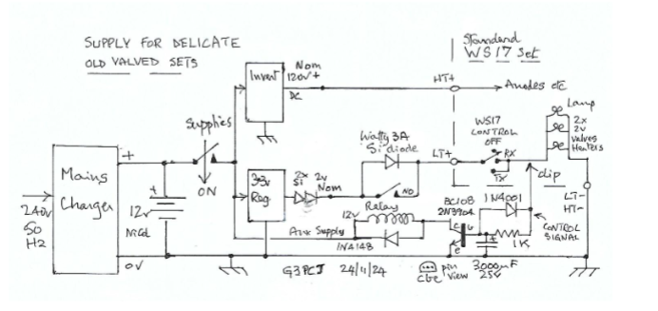
--------------------------------------------------------------------------------------------------------------------
* Information about filament voltages for expensive transmitting tubes is supplied by W8JI and is found at this link, where he cautions about over/under voltage and provides some good safety practices.
* Another way to decrease inrush current is by using a properly rated thermistor in the filament transformer lead. The Ametherm website page provides a great deal of information about these and about Inrush Current. A list of part numbers and specifications can be found on their home page. Those with technical/engineering knowledge are asked to provide any additional information about the use of these devices. It is normally placed in the transformer primary input line but in cases where both the HV and the filament voltages are obtained from the same transformer, a thermistor may be put in the output lead of the filament secondary winding and another placed in the HV circuit, directly after the bridge rectifier. This assumes that the filament and HV are switched on separately.
* Here’s an article by Peter regarding a simple but effective Soft Start circuit:
A simple and reliable ‘soft start’
Imagine if you will a power supply, fed by AC mains, and feeding a load, which could be
DC (via a rectifier) or AC for filaments, or other ‘delicate’ load which, when de-energised,
becomes very low resistance - for instance tungsten filaments can be 10 times lower
resistance when cold, than when hot. These loads draw large inrush surge currents when
first energised, that can ‘pop’ a delicate or rare filament (see Tim Walford’s article in this issue), and even cause a dip in the mains incoming which can upset nearby connected equipment.
A simple and effective way to stop inrush surge in an HV DC supply, uses a resistor and a single pole relay (with coil rating to suit the desired output voltage) it’s n/o contacts shunting a resistor in live line to the HV transformer. Simply put the power resistor in series with the power supply transformer ‘live’ feed (after fuses and isolation switches as per normal safe circuitry practice) shunted by the normally open relay contacts - then feed the relay coil via a resistor (if needs be) from the power supply output so that the relay operates when the output voltage has risen to roughly 75% of the desired output.
How does this scheme work? Well… the line resistor holds the inrush current back, so
the output rises slowly as the smoothing capacitors charge. Once the output has risen to
roughly 75% of expected output, the relay pulls in - applying full mains volts to the power
supply transformer primary, and is held in as long as mains is applied.
This technique can be readily adapted to AC circuits too by scaling the resistors
appropriately; or perhaps a small transformer to ‘sense’ the output and control the limiting resistor’s shunt relay. The variations are manifold; use your imagination! Note too the coil feed resistor and relay coil in the DC style also act as a bleed resistor, safely discharging the HV smoothing capacitors. I reckon ‘two jobs for the price of one’ is a fair bargain!
You’ll need to guess-timate the relay coil dropper resistor, a bit of ‘cut and try’ will soon give a result that works.
------------------------------------------------------------------------------------------------------------

2
* Using discarded microwave oven transformers (MOTs) to provide HV in a home brew linear amp is a common practice where saving money is important. These will experience a large input surge if turned on at a certain point of the AC mains waveform, sometimes causing the house circuit breaker to trip, so it is good practice to put a thermistor or a soft start circuit in the primary lead of these transformers. There is a wealth of information on the internet about MOT uses. Be careful, though – these are highly dangerous if misused and remember that one end of the secondary winding is connected to the MOT frame.
------------------------------------------------------------------------------------------------------------------------
* Here’s a nice easy-to-build NE612 Direct Conversion receiver, with an audio-derived AGC system:
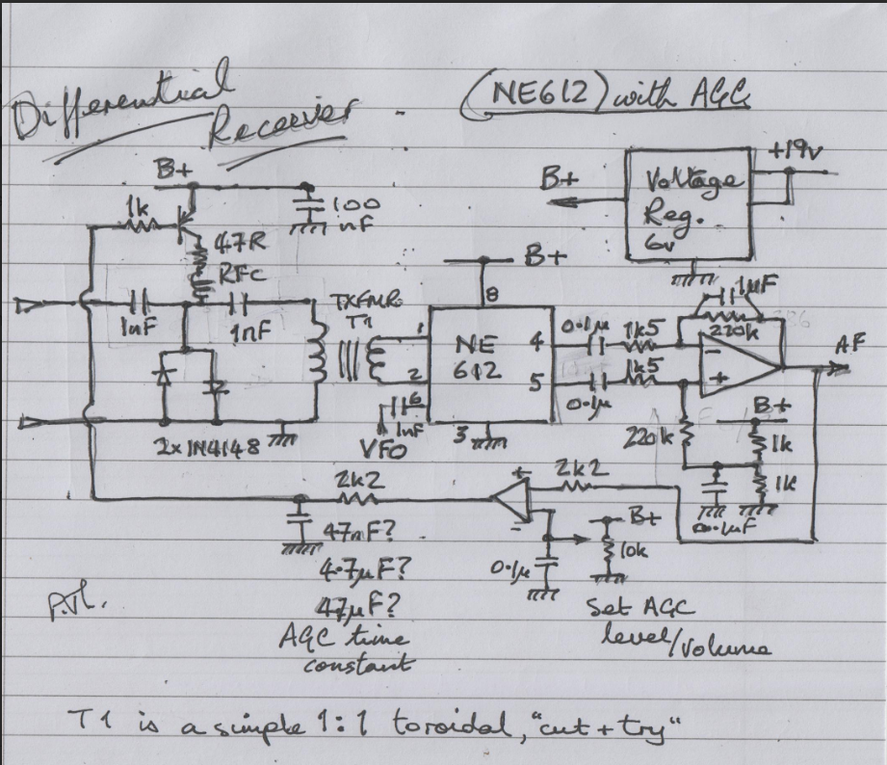

A few comments about this receiver: The RFC’s are 100uh but the very-available 2.5mh units might work as well. It might be helpful to add one to pin 8 to keep any RF out of the B+ system. The 1:1 toroid was one used in a 120/240 volt AC input filter circuit. Try 12 turns on each side, tapping up or down if needed to bring the signal in. The PNP transistor is a BC327 but nearly anything will do. The op-amp could be a 741; again many types will work. The audio amp could be LM386 or one of the TL family members. Your choice.
---------------------------------------------------------------------------------------------------------------------------
* For those constructing a receiver of almost any type, G3RJV (SK) has provided a page describing simple band pass filters to add to the front end of the project receiver. The page is at this link. The required KANK IF transformers are still available from various sources. If you can’t find them, G4COE has provided instructions to make your own using simple windings on common toroids. We are indebted to GQRP club for making these documents available.
--------------------------------------------------------------------------------------------------------------------------
* A few of us troglodytes still have WWII era LM or BC series heterodyne frequency meters. They are signal generators and Dr. Greg Latta, AA8V, shows how they can be used as VFO’s to drive our ancient tube transmitters, by using a small RF amplifier and a step-up transformer to increase the unit’s output. After 15-20 minutes of warm-up, the accuracy and stability of these tube units will rival many presently-produced solid state units. Frank has three (an LM-8 and two BC-221’s), which might be an indication of a hoarding affliction. The LM series dates back to at least 1936 and here is a thorough report on the early units’ accuracy. I believe my LM-8 was manufactured in 1940 and it is original and as steady as a rock...it’s a year older than me and more stable than I am. Frank, W4NPN
_______________________________________________________________________________
The End Fed Half Wave Antenna has been a very popular topic lately, especially for portable use, due largely to the ease with which it can be erected. In the Ham Radio Outside the Box website, VA3KOT explores whether or not it can be a multiband antenna.. Spoiler alert: A lot of variables can affect this thing!
Here’s a quote from W8JI about this antenna: “A properly built and installed G5RV is a better option than an end fed half wave so long as the central feedpoint can be tolerated.” Go here to read the whole W8JI article.
------------------------------------------------------------------------------------------------------------------------------------
* Radio Shack is back? The Unicomer Group, a San Salvador, El Salvador-based corporation is operating an on-line store version selling hundreds of products but not individual parts like the original stores did. It’s a product retailer with a familiar name. The original RS was a USA store-based operation that closed some years ago.
-----------------------------------------------------------------------------------------------------------------------
* https://www.worldradiohistory.com/index.htm features magazines such Popular Electronics, Radio & Electronics, etc.
* KD4E has a helpful website containing USA licensing Exam Practice, links to swap and commercial sales sites, and surplus sites. Check it out!
* So your 3-500Z (or similar) expensive tube just died? Ouch! Go to the blue link and scroll down to the bottom of the linked page to find some hope for fixing it.
* Amateur Radio Weekly #358 features “The Best Raspberry Pi Ham Radio projects,” an article of interest to many. #358 also includes a link to MorseLink which allows chatting online using morse code – a great way to practice. There is also an article about how Brazilian radio pirates have tapped into retired UHF Military Satellites (280 – 310 mhz), using modified handheld devices, to create an unusual communications system.
* Zero Retries #0180 also has some Raspberry Pi projects so check this out and have a look at the archives while you are there.
* Repeaters, Repeaters, Repeaters. This website has it all: Repeater Builder is an informational help site owned by Kevin Custer, W3KKC.
* Remembering that this newsletter is the “Journal of the Constructor’s Club,” we are searching for simple but fun projects to build. Kits are fun and useful but building “from scratch” is even more fun, especially if most or all the parts can be found in your junk box or in something waiting to be scrapped. Below, we have a quick look at some high-efficiency Class-E designs.
* VK3YE has a list of QRP projects and excellent operating advice to go along with the projects.
-------------------------------------------------------------------------------------------------------------------------
Ham Radio Clubs and Organizations:
Burnley & District Amateur Radio Club - MX0STB This club, in Lancashire, UK, currently has 34 members and has recently acquired some surplus gear from another UK amateur.
Raleigh Amateur Radio Society, located in Raleigh, NC, USA, has many members and holds one of the nation’s largest “Hamfests” each Spring. It also holds licensing and training sessions and has a significant public service component.
GQRP low-power club was formed in 1974 by Rev. George Dobbs G3RJV (SK). It is a non profit organisation run entirely by volunteers to promote Low Power Radio (QRP) . Whether you have a ham licence or not - everyone is welcome. The quarterly magazine SPRAT provides a fascinating read containing articles of varying complexity, from simple test equipment, to fully functioning radio transmitters and receivers. You can access SPRAT from the GQRP website and the annual cost of membership is very inexpensive. GQRP also has a YouTube Channel at this link.
Four States QRP club has ideas and features focused on QRP operations and construction.
The Michigan QRP club has a simple DC Receiver kit which might still be available.

(Let’s get your club listed here - send the information to Frank at w4npn@gmail.com!)
TIDBITS:
* William R. Hepburn runs the DX Info Centre Tropospheric Ducting Forecast website which provides six-day tropospheric ducting information and forecasting for those interested in exploring VHF, UHF and Microwave DX through the use of these ducting channels. These have the necessary atmospheric conditions to produce tropospheric bending of the waves, which extends the range of stations well beyond normal limits. Frank has experienced some of this while living in Saudi Arabia and receiving FM stations from Israel for periods of a few hours, and also receiving a New York TV station while living in Florida.
* Ham Radio Outside the Box has an interesting article about the new QRP Labs QMX transceiver.
* Ray Osterwald, N0DMS, publishes the Electric Radio magazine which contains articles about tube gear and older technologies in each issue. For example, the Sept/Oct issue has an interesting article written by WA2EJT, about the old Ohmite D-100 Dummy Antenna Resistor in the form of a large globular clear glass light bulb shape. Much information about its construction and successor models is included.
* Rudy, at Mouser, a major supplier of electronic components, publishes a series of “Tech Tuesdays” articles, many of which are of direct interest to hams and those of us who like to build stuff. Here’s the latest listing (be sure to scroll down and click the “See More” button!)
* We’ve become aware of The Communicator, a magazine-quality publication of Surrey Amateur Radio Communications. It is indeed an impressive magazine, edited by John, VE7TI, located in Surrey, BC, Canada. The July-August edition can be read at this link. It contains many articles of interest, including one about the mysterious Russian broadcast at 4,625 kHz.
* QRPpppp and WSPR allows you to check your antenna’s multi-band transmitting and receiving performance. This article by N2YCH discusses this using available software and common techniques.
* This Zero Retries link discusses the 902 – 933 (33cm) band and what’s happening there, including some distance records for 802.11ah modem transmissions.
--------------------------------------------------------------------------------------------------
The Section below is a more-or-less “standard” section of the newsletter
which we hope to repeat repeat in each issue:
* AM Broadcast Coverage Night Patterns, for U.S. and Canadian MW stations (created by NF8M). Pick any MW frequency and see the typical coverage areas. A unique service!
* Antenna Headings: VU2NSB provides a handy tool to show compass bearings to “everywhere” once your Maidenhead grid square is entered. Here is the link to that handy tool.
* Amateur Radio Weekly has many topics of interest; have a look!
* Similarly, Zero Retries has many articles of interest
* Christian, G5DOC writes about Meshtastic-enabled LoRa devices...this is new to Frank and quite interesting! Hackaday also has an article about LoRa networks – give it a read. Oh, wait – there’s more: Go here to read about mesh-compatible LoRa.
* Tom Salzar’s February 23rd Ramdom Wire Review has a lot of articles of interest such as:
“Why we need Shortwave.”
* HamRadioWorkbench.com has a lot of nifty podcasts, projects and articles to peruse.
* The Random Wire newsletter has a lot of computer articles in it and it informs us that the Analog Engineer’s Pocket Reference (a handbook) is available from Texas Instruments as a free download. Go here to get or read a copy (it’s a .pdf download). Look under the “Miscellaneous” column of the website page that appears when you click the “Go here…” link.
* The DLARC library contains the entire run of 73 magazine issues
* https://www.worldradiohistory.com/index.htm is an archive that features magazines such Popular Electronics, Radio & Electronics, etc.”
YouTube Channels we have found (please let us know of others that you know about):
HB9BLA Wireless by Andreas Spiess HB9BLA
KM6LYW Radio by Craig Lamparter KM6LYW (home of the DigiPi project)
Modern Ham by Billy Penley KN4MKB
Tech Minds by Matthew Miller M0DQW
7
Other Ham-related Newsletters (please let Frank know of others not listed here):
* 73 from G5DOC covers many subjects. From this link, scroll to the end to find many subjects to investigate
* The Communicator has been recommended by VE7SAR – give it a look!
* Here’s a link to the ARRL newsletter, which has many pages of news of interest to us hams.
* DxZone publishes a substantial list of amateur radio newsletters. Have a look!
* The QRZ Forum contains news, technical information, discussions and equipment evaluations; there is much to read here!
* This DX Engineering website has 31 pages of news and general information about ham radio. Many antenna and feedline articles are included.
* QRP Guys advertises kits and circuits
* QRP ARCI is a club for low power enthusiasts worldwide.
* The American QRP Club is for builders, experimenters, and low power enthusiasts.
* VK3YE’s QRP website is not a club but it provides a lot of information about QRP operations.
* The DXZONE provides a list of QRP websites
* Check out the various sections of www.w4npn.net, the website where the Hot Iron newsletters are hosted. There is much more there! Another rabbit hole.
Disclaimer: We have no ties with any commercial company mentioned in Hot Iron editions or on the w4npn.net website.
Please share Hot Iron with your friends and radio clubs, etc.! There is no cost and we do not share the address list with any other organization. This is the link to the Hot Iron homepage, which has a subscription form.

