HOT IRON #127: November, 2024
THE JOURNAL OF THE CONSTRUCTOR’S CLUB

Technical Editor: Please send technical questions and suggestions to Peter, G6NGR
Content and Distribution: Send ideas for content or subscriptions to Frank, W4NPN
Hot Iron Library of issues (.pdf downloads) Hot Iron Searchable Compilation-all issues
Hot Iron Index; subjects and issues Hot Iron Technical Library
================================================
Our wonderful hobby includes participants with a great deal of electronic knowledge as well as those just beginning their journey. Some prefer digital modes and projects, others prefer analog projects and devices that glow in the dark. Our quarterly newsletter tries to publish a little something for each!
* Insulated gate bipolar transistors (IGBT) offer some amazing power amplifier capabilities, as the author’s experiments show. Have a look at this article published by the ARRL. If anyone knows of more investigation into this area, please let us know.
* Sunspots & Solar Activity: Have you installed that 10-meter antenna yet? The sun has reached its solar maximum (magnetic activity) for this portion of its 11-year cycle and it is expected to last for about another year. The sun flips its N-S magnetic poles once every 11 years and sunspots are used to judge the sun’s magnetic activity. Sunspots are cooler regions in the sun’s fields of magnetic activity. During the most active part of the cycle, known as the solar maximum, the sun can create immense explosions of light, energy and solar ratiation, all of which create “space weather.” This can affect satellites, GPS and communications systems on earth and even affect power grids in extreme cases.
* A Solar Powered LoRa project is featured in this issue of Elektor Mag. “Autonomously operating sensor nodes need wireless communication as well as an autonomous source of power. This article introduces you to a battery-powered Internet of Things (IoT) node, buffered by a solar cell, with LoRaWAN connectivity. “
PROJECTS:
* The August, 2024 Hot Iron provided sample schematics of some low-power and mostly solid state transmitters, to build for some weekend fun. Some tube examples (mostly higher power) are below.
* Peter has provided this example of a single dual-section tube AM medium wave transmitter; one section is the modulator and the second is the oscillator/output. Seems simple; crystal controlled. Check for harmonics! It could be modified for short wave use. The author provides a great deal of technical information about the circuit, which should be helpful if moving it to short wave use.
* Below is another crystal-controlled transmitter called “The Pink Brazilian,” (who knows why it is called that?) which uses a PL519 final amplifier. It has been around a while but is shown here as an idea-generator. Note that this is a Medium Wave transmitter which can be scaled up to short wave frequencies. There is little harmonic suppression so watch out for unintended emissions! And look at the power supply which uses a voltage doubler HV supply bolted directly to the 220 VAC mains without an isolating transformer. That’s a kamikaze power supply!

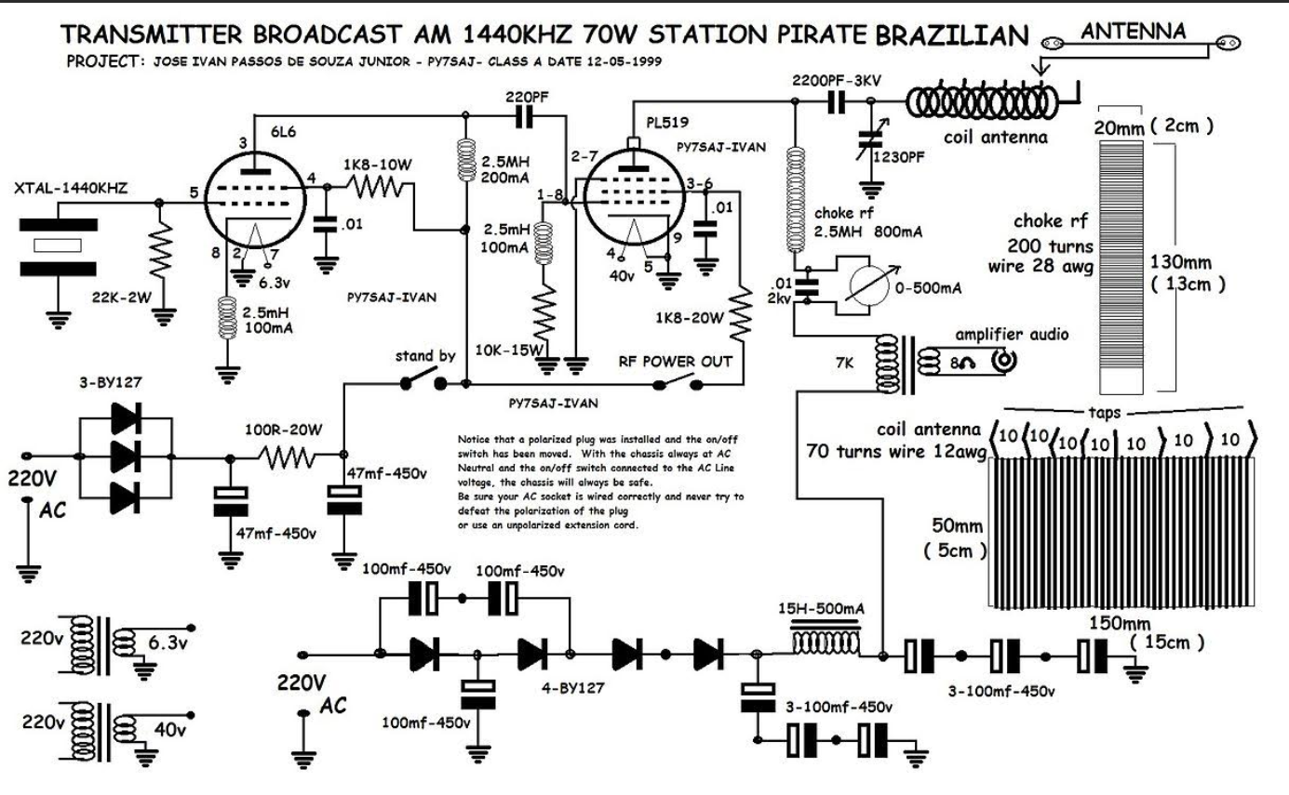
Next is a classic 807 transmitter, designed by K5DH. Note that it can be frequency-controlled by either a crystal or a VFO, which is nice. Its clean design should have good harmonic suppression due to the presence of the “wave trap” filter between the 6AG7 and the 807. It uses plug-in coils but switched coils should not be difficult to implement, so that opening the cabinet is not required when switching bands . Depending on the high voltage, it will produce about 75 watts input. Put a second 807 in parallel with the single one and you’ll have a nice 150 watter. 807’s are found cheaply at hamfests and they are extremely rugged, especially the 5933/807W “ruggidized” variant. One design was seen that had 1100 volts on the plates – that’s real tube-abuse!
Prior to construction it might be helpful to read this W8JI page about screen supplies and the need to keep the 807’s screen voltage from soaring during key-up periods. This page will also provide some good information about screen voltage stabilization; scroll down to the “cathode keying” section.
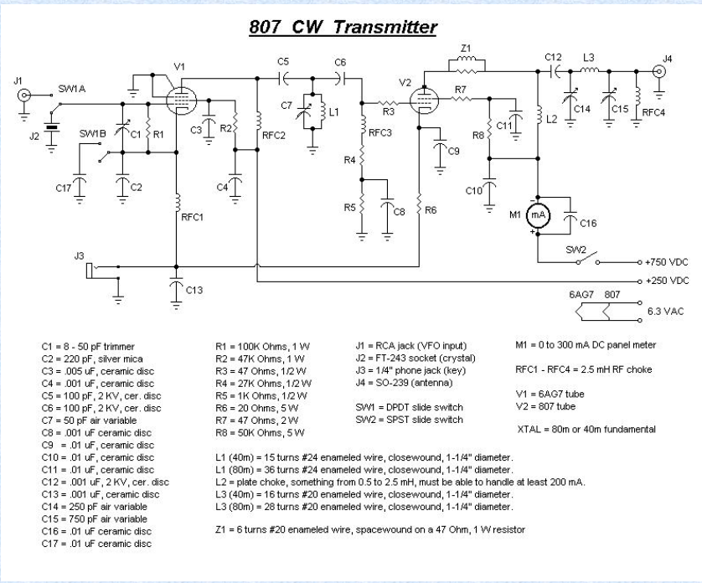
Here is a link to the 807’s tube characteristics.
Below is a helpful table from the 1957 ARRL Handbook, which shows tank circuit values for one and two 807 tubes, using 750V & 100 ma (single) and 750V & 200 ma (two tubes). This should be helpful when designing your own antique transmitter. The 807W’s are nearly indestructible so don’t be shy of experimenting with them.
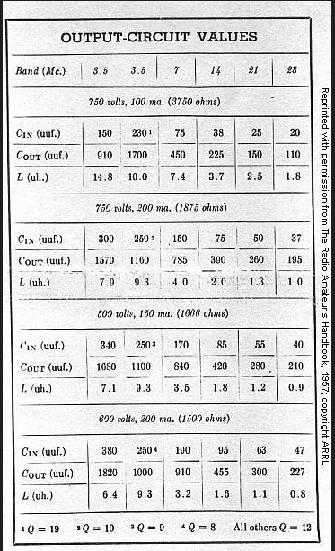

How do you tune up one of these old circuits? Many who use modern solid state transmitters and automated tuners will not be familiar with the process. Use CW mode for tuning. It’s simple: Set your Cin and Cout to approximately the values given in the table. Make a guess as to what you think is the proper coil tap, then rotate Cin for a plate milliamp dip. Now the final is resonated. For loading, rotate the Cout for maximum milliampers. Repeat this. Your Cin and Cout positions should roughly correspond to those in the table. If not, change the coil tap and repeat the process.
If you cannot achieve 100 ma (one tube) with 750 volts, adjust the coil tap and repeat the process until you have reached the most efficient values (maximum output). Record these settings and it will be easy to change bands in the future. It is recommended to begin the process on a low band, rather than, say, 10 meters. An outboard Field Strength Meter is also helpful in maximizing the radiated power.
It is important to know that you have tuned up on the proper band – not on a harmonic frequency! That’s why the “wave trap” LC between the oscillator/buffer and final stages is important. For instance, if using a 3.6 mhz crystal and doubling it up to 7.2 mhz, it would be easy to accidentally load on 3.6 mhz or even 10.8 mhz if no wave trap was used. You can make checks to establish proper control positions for the desired band, by listening on a receiver for harmonics (or, we hope, the lack of them). Once you have determined the proper settings, you will not have to repeat this process.
Need a HV power supply for your tube transmitter? W8JI provides an efficient and economical design, seen below, to produce three voltages: HV, screen and bias, from a single transformer. R1 represents the plate load of your final amplifier tube. R2 represents the B+ load for screens, etc, and R3 is the negative bias load (note how it rectifies the AC ripple across the 10 henry choke placed in the negative line of the diode bridge).
In the 807 transmitter circuit above, no bias voltage is required (it’s self-biased) so the negative line of the diode bridge in the power supply design below can go directly to ground. R5 and R6 are to provide a “soft start” to the diode bridge and can be omitted if a “soft start” or varistor system is incorporated in the primary side of the transformer. If using a robust transformer and diode bridge, all “soft start” could be omitted, but some form of soft start is usually a good idea.
Addendums to the circuit displayed include:
1) If you are concerned about meter safety, consider not putting the plate milliamp meter in the HV line. Although this provides the exact plate current, it’s a bit dangerous. Instead, put it in the rectifier negative lead. This causes the leakage MA through the filter caps, equalizing resistors and any bleeder resistor, to be included in the reading but you can mentally adjust for that.
2) Add a high voltage fuse immediately after the rectifier, in the high voltage line. Don’t use a 120/230 VAC fuse for this function. Get a HV Microwave oven fuse from Amazon or Ebay; they are cheap.
3) Also, add a 50 ohm, 10 to 50 watt “glitch” resistor after the fuse. The glitch resistor will absorb a possible flashover (i.e., instantaneous short circuit) that might occur in the final amp circuit, before it hits, and blows the fuse.
4) Not shown in the design is a “bleeder” or “safety” resistor, used to discharge the filter capacitors when the system is turned off. With a 700 volt B+, a 70K, 10 or 15 watt resistor would provide a 10 ma bleed. 100K, 10 watt would provide a 7 ma bleed. Use Ohm’s Law (E=IR) to determine these resistor sizes.
What we want for a bleeder is one that will bleed down the HV in the time it takes to back out the screws on the transmitter’s cover and remove it, so that the unit is mostly safe at that point. And first unplug it from the mains!
It is true that the equalizing resistors will also bleed down the HV at system turn-off, and many modern designs will omit the “safety” bleeder.
One could also install an interlock system that quickly bleeds the HV through a 10K resistor when the cover is removed, before we stick our fingers into the inner workings of the power supply. But hey, we cats have 9 lives, right?

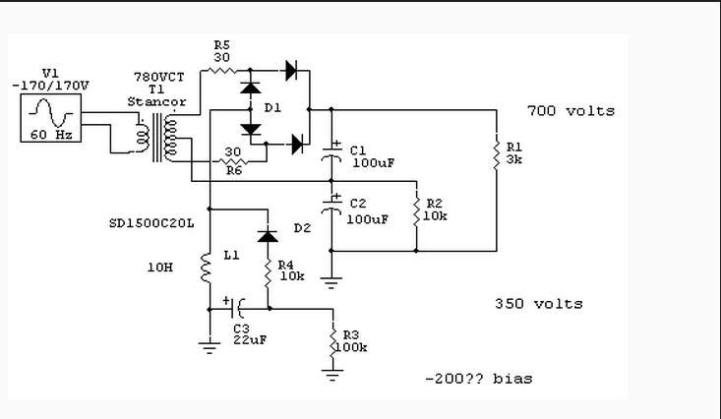

Well, you built a 6L6, EL84, 807, 6146 or similar transmitter, but how do you modulate it if you want an AM transmitter, rather than only CW? Internet searches will reveal a thousand designs. There are three common, classic options (many other types, often more esoteric or complex ones, also exist):
1) Plate modulation: This provides the most power out, but requires a sometimes expensive and heavy plate modulation transformer as well as a considerable audio amplifier. If running low power, an audio output transformer might do the job cheaply.
2) Screen modulation: This is fairly simple and Heising Modulation is a variant of this.
3) Cathode modulation: This is probably the simplest. An old example circuit that works very well is found at this link.

OK, now you’ve built a transmitter that glows in the dark, and uses cathode keying, but you aren’t very good with a hand key, and would like to use a keyer for transmitting. Modern keyers cannot stand the voltage present in a cathode keying circuit, so how can we adapt them for use in a cathode keying circuit? Here’s the answer – a simple circuit, from WA5BDU.
* Remembering that this newsletter is the “Journal of the Constructor’s Club,” we are searching for simple but fun projects to build. Kits are fun and useful but building “from scratch” is even more fun, especially if most or all the parts can be found in your junk box or in something waiting to be scrapped. Below, we have a quick look at some high-efficiency Class-E designs.
* Class E transmitters can achieve amazing efficiencies and are not necessarily complex. The
modern take on Class E in the articles cited below show this is becoming better realised as time goes on. Woe betide though, anyone who wants a transmitter for multiple frequencies! You'd certainly struggle to cover the 80m band with a Class E P.A. as you'd need to make a lot of hefty RF bits adjustable, but for fixed frequency (xtal controlled|) transmitters Class E will save some tonnage usually expected in an A.M. Tx, especially using Drain / Supply modulation schemes.
This article from KA7OEI discusses the design of a simple Class-E switching-type LowFER Beacon transmitter. Close to 100% efficiency is achieved with a minimum of parts and a good analysis of the circuit is provided.
This link describes a 200 watt Class-E transmitter and provides much amplifying information about the mosfets used, possible alternatives and other thoughts.
Here’s an explanation and schematic for the “TEXAS” Class-E LOFER beacon. Lots of reference material is provided, along with an excellent analysis of the circuit.
For a little more versatility, here’s an article about a 30 meter WSPR transceiver!
For a more technical education about Class-E, read this paper by Sokal.
Internet research will find many, many design and explanatory articles about Class-E, and the weather will soon become too cold to do much outside so have a look!

Ham Radio Clubs and Organizations:
Burnley & District Amateur Radio Club - MX0STB This club, in Lancashire, currently has 34 members and has recently acquired some surplus gear from another UK amateur.
Raleigh Amateur Radio Society, located in Raleigh, NC, USA, has members and holds one of the nation’s largest “Hamfests” each Spring. It also holds licensing and training sessions and has a significant public service component.
Let’s get your club listed here - send the information to Frank at w4npn@gmail.com!
TIDBITS:
* For the ham who has everything: Hackaday features a design for a VLF receiver that listens to the millions of lightning strikes that hit the earth everyday. The hobby is called “spherics” (atmospherics).
* MFJ Enterprises, a major supplier of ham radio products and parts, has ceased operations after the founder and owner turned 80 years old and wants to retire. It will be missed. Read the linked article about his life and the company.
* Radio World reports that “pirate station” Radio Caroline has returned to AM broadcasting 24/7, on 648 khz. Of course, they also stream on the internet (doesn’t everyone?).
* This article shows that San Francisco Bay tide levels do not affect reception. Who knew? Thanks to Amateur Radio Weekly for the report!
* Ray Osterwald, N0DMS, publishes the Electric Radio magazine which contains articles about tube gear and older technologies in each issue. For example, the Sept/Oct issue has an interesting article written by WA2EJT, about the old Ohmite D-100 Dummy Antenna Resistor in the form of a large globular clear glass light bulb shape. Much information about its construction and successor models is included.
* Rudy, at Mouser, a major supplier of electronic components, publishes a series of “Tech Tuesdays” articles, many of which are of direct interest to hams and those of us who like to build stuff. Here’s the latest listing (be sure to scroll down and click the “See More” button!)
* We’ve just become aware of The Communicator, a magazine-quality publication of Surrey Amateur Radio Communications. It is indeed an impressive magazine, edited by John, VE7TI, located in Surrey, BC, Canada. The July-August edition can be read at this link. It contains many articles of interest, including one about the mysterious Russian broadcast at 4,625 kHz.
* Some Vacuum tube trivia, courtesy of Richard Knoppow, WB6KBL: “Since the teens, incandescent lamps have used "coiled coil" filaments running in an atmosphere of noble (i.e., nonreactive) gas. This is sometimes attributed to Irving Langmuir although the precedence is disputed. Langmuir was a research scientist working for General Electric. He is also attributed with discovering that vacuum tubes needed to operate with a hard vacuum and inventing a vacuum pump suitable for mass production. Simultaneously and independently this was also discovered by Henry de Forest Arnold of Bell Laboratories. An agreement between GE and Bell labs ended litigation over precedence and resulted in both GE and Western Electric/AT&T having rights to manufacture vacuum tubes. They were able to demonstrate to the satisfaction of a court that Lee de Forest did not understand the necessity of a hard vacuum and as a result invalidated many of de Forest's patent claims regarding vacuum tubes. De Forest thought the presence of gas in a tube was necessary to its
operation.
Both Langmuir and Arnold are worth reading about. Incidentally, I was told by a friend (now SK) who was with Bell Labs, that Arnold was a wonderful researcher who was promoted to manage the laboratories because it was the only way Bell Labs could increase his pay, but he was not a good administrator.“
* How far we’ve come – Browse through this April, 1934 issue of Radio Magazine to see the very latest in radio technology at that time. Link Coupling, anyone?
* Spaceweather.com continues to show high sunspot numbers – over 200. 20 meters and above should continue to be very active for some time to come. Thanks to Amateur Radio Weekly for reporting this.
* Zero Retries issue 168 has a lot of information about the potential loss of the 902 – 928 MHz frequencies, use of which is desired by NextNav.
* The Antique Wireless Association of Southern Africa has an interesting article about clandestine Nazi spy radio transmissions during WWII. See their September, 2024 Newsletter.
* Amateur Radio Weekly #347 informs us that NASA is developing a new time standard: Coordinated Lunar Time (LTC), to provide a time standard usable in space. Time will be determined by a weighted average of times from a number of atomic clocks placed on the moon. Time on the moon is a bit different from earth time (I didn’t know that!), and it “ticks” a few microseconds faster every day compared to time on the Earth so mathematical models will be needed to adjust for this. Quite an improvement over an ancient Egyptian sundial.
* ARW #347 also links to an interesting article about the development and status of the GPS system and its current 31 satellites, the oldest of which is 27 years old and still performing!
* The MIT Technology Review has an article we should all read concerning radio communications and drone technology being used in the Ukraine war.
* Information about Space Weather, cosmic radiation, solar cycles and much more is here.
* QRPpppp and WSPR allows you to check your antenna’s multi-band transmitting and receiving performance. This article by N2YCH discusses this using available software and common techniques.
* Need to prepare for an AllStarLink build? Read this KJ7T “The Random Wire” newsletter issue to get started.
* Many countries have shut down their short wave broadcasting systems in favor of the internet but Radio New Zealand Pacific is installing two new 100 KW transmitters aimed at the South Pacific islands. This is most refreshing! Read the linked article about RNZ’s effort from Radio Report Smartbrief. Another recent announcement states that VOA is closing its Marianas Island transmitter site.
* This Zero Retries link discusses the 902 – 933 (33cm) band and what’s happening there, including some distance records for 802.11ah modem transmissions.
* There have recently been articles about WB3GCK’s “Loudspeaker Wire Antenna,” which claim good multi-band success. John, VK3KOT analyzes it and comes to some conclusions which can be read at this link.
--------------------------------------------------------------------------------------------------
The Section below is a more-or-less “standard” section of the newsletter
which we hope to repeat repeat in each issue:
* AM Broadcast Coverage Night Patterns, for U.S. and Canadian MW stations (created by NF8M). Pick any MW frequency and see the typical coverage areas. A unique service!
* Antenna Headings: VU2NSB provides a handy tool to show compass bearings to “everywhere” once your Maidenhead grid square is entered. Here is the link to that handy tool.
* Amateur Radio Weekly has many topics of interest; here’s a sample:
* Similarly, Zero Retries has many articles of interest
* Christian, G5DOC writes about Meshtastic-enabled LoRa devices...this is new to Frank and quite interesting! Hackaday also has an article about LoRa networks – give it a read. Oh, wait – there’s more: Go here to read about mesh-compatible LoRa.
* Tom Salzar’s February 23rd Ramdom Wire Review has a lot of articles of interest such as:
- Why we need Shortwave, and, a text file for the internet
- He also has a long article about his journey through Ham Radio, which many of us can relate to.
- More, and look at the archived issues – there is a lot there!
Issue 98 (July 12) is AllStarLink heavy! ASL 3 Beta gets installed on a virtual machine and connected to an SIP phone. This doesn't work like ASL 1 and ASL 2.
* HamRadioWorkbench.com has a lot of nifty podcasts, projects and articles to peruse.
* The Random Wire newsletter has a lot of computer articles in it and it informs us that the Analog Engineer’s Pocket Reference (a handbook) is available from Texas Instruments as a free download. Go here to get or read a copy (it’s a .pdf download). Look under the “Miscellaneous” column of the website page that appears when you click the “Go here…” link.

YouTube Channels we have found (please let us know of others that you know about):
HB9BLA Wireless by Andreas Spiess HB9BLA
KM6LYW Radio by Craig Lamparter KM6LYW (home of the DigiPi project)
Modern Ham by Billy Penley KN4MKB
Tech Minds by Matthew Miller M0DQW

Other Ham-related Newsletters (please let Frank know of others not listed here):
* 73 from G5DOC covers many subjects. From this link, scroll to the end to find many subjects to investigate
* The Communicator has been recommended by VE7SAR – give it a look!
* Here’s a link to the ARRL newsletter, which has many pages of news of interest to us hams.
* DxZone publishes a substantial list of amateur radio newsletters. Have a look!
* The QRZ Forum contains news, technical information, discussions and equipment evaluations; there is much to read here!
* This DX Engineering website has 31 pages of news and general information about ham radio. Many antenna and feedline articles are included.
* QRP Guys advertises kits and circuits
* QRP ARCI is a club for low power enthusiasts worldwide.
* The American QRP Club is for builders, experimenters, and low power enthusiasts.
* VK3YE’s QRP website is not a club but it provides a lot of information about QRP operations.
* The DXZONE provides a list of QRP websites
* Check out the various sections of www.w4npn.net, the website where the Hot Iron newsletters are hosted. There is much more there! Another rabbit hole.

Future Quarterly Newsletter Content – make a suggestion! Some subjects we are considering:
Crystals and Crystal Oscillators, a VFO issue, Regenerative Receiver designs, Classic Xmtr designs, Power Supplies. What interests you? Let us know!
Disclaimer: We have no ties with any commercial company mentioned in Hot Iron editions or on the w4npn.net website.
Please share Hot Iron with your friends and radio clubs, etc.! There is no cost and we do not share the address list with any other organization. Send subscribing requests to Frank at fbw4npn@gmail.com

