HOT IRON #122, NOVEMBER, 2023
THE JOURNAL OF THE CONSTRUCTOR’S CLUB

Technical Editor: Please send technical questions to Peter, G6NGR
Content and Distribution: Send ideas for content or subscriptions to Frank, W4NPN
Hot Iron Library of issues (.pdf downloads) Hot Iron Searchable Compilation-all issues
Hot Iron Index; subjects and issues Hot Iron Technical Library
========================================================================

Our wonderful hobby includes participants with a great deal of electronic knowledge as well as those just beginning their journey. Our quarterly newsletter tries to publish a little something for each!

Unhealthy sedentary issues...
...the medical effects of too much sitting are not to be sneezed at. Humans weren’t
designed for long term (i.e. over an of hour or two per day) bum perching!
The benches we worked at assembling Test gear were nominally 900mm high; some a bit
more some a bit less, and it was noticed that the taller gravitated to the higher benches
and rthe shrimps to the lower echelons (only joking). But - the truth of the matter is that
wiremen standing at (high) benches eliminated backache. The only sitting (apart from tea
break) was to assemble circuit boards where a flat bench top assisted soldering and the
provision of adjustable support frames that could be flipped over for component insertion
made the (through hole) assembly a doddle.
One other point about sedentary working: it was noticeable that the assemblers (both male
and female) who stood were trimmer, fitter and in general in better health as shown by
time off for medical matters.
Later life comes hopefully to all of us; if you can, consider limiting sedentary working and
adopt a more upright posture. My local Doctor, bless him, has one of those desk supports
for his computer keyboard and display which puts him nigh on vertical. I asked about this;
he said it had worked wonders for the “aching back” he inevitably suffered when sitting all
day at a desk, and he found no problem in standing for a full 12 hours shift at the Medical
Centre once he’d had a few weeks to acclimatise.

* Zero Retries newsletter #122 has several articles of interest, including FCC’s proposal to delete symbol rate limitations and the new Elecraft KH-1 CW-only hand-held transceiver. Click the link!
* Ask the Readers: If we use half a 74HC74 dual D type flip flop as a Huff-n-Puff phase comparator in a VFO design, how should we use the other half of the chip as an inverter to make the reference oscillator? Chris Fletcher, G3DXZ, in Hot Iron #33, pg 5, described a capable H-n-P that readers could well try until experiments prove or disprove the 74HC74 for oscillator service. Please send your responses to Peter.

* Ray, the editor of Electric Radio Magazine, has allowed us to have a copy of WA6VVL’s article about building a crystal calibrator for your radio. Very simple and straight-forward, using a 6BZ6 (a semi-remote cutoff pentode); it can be adapted to most tube receivers. The more common 6BA6 might also work in this circuit. Here’s a schematic but read the short article first.
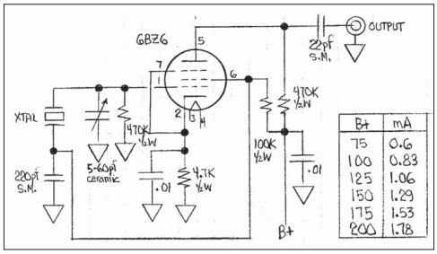

Hot Iron #33 has a simple solid state crystal calibrator version;. See page 4.

Creating a Linux-based HF Packet BBS is an article in issue#304 of Amateur Radio Weekly.

Readers Please send designs for transmitters using the venerable 6L6 tube as the final amplifier. Cathode modulator schemes using a MOSFET (for any tube) would be appreciated too! Send these ideas to Frank at fbw4npn@gmail.com.
Solar Cycle 25: SC 25 might peak much earlier and much higher than was previously estimated, due to the sun’s greatly increased solar activity. Geomagnetic storms can create havoc with our power distribution systems and cause great damage to our digital world. 14,300 years ago a massive solar storm occurred. Should another of that size occur, the damage would be extreme and deadly as we are completely dependent on reliable electrical systems; many would be out of service for months.

Regens - and all that: Straight Regens: There are literally zillions of designs for these beasties, take your pick - try a few circuits and you’ll soon be a confirmed “regen” user.There are several options open to you, depending on how you set up the circuit, but they boil down to either a ‘soft’ oscillator or
‘hard’: soft meaning that as you tune across a band, the circuit will jump to synchronise
with a carrier or CW signal. ‘Hard’ means that the circuit will remain tuned exactly to the
frequency you’ve set in the presence of carriers nearby, and you’re very close to a direct
conversion receiver.
These receiver types acquired various names - the ‘soft’ oscillator type sometimes known
as ‘Autodyne’ which only just oscillated happily to itself but locked onto an incoming carrier
- were useful in poor signal areas where the incoming (A.M.) signal drifted or faded - the
circuit held lock onto the carrier.
This attribute can bring a rather strange result when trying to demodulate CW Morse! But considering you’re achieving amplification of several million times and demodulation in one transistor or valve, it is nigh on a miracle.
The main feature of an Autodyne is the ‘reaction’ control: this sets the level oif positive feedback, and by appropriate tweaking can set the circuit ‘on the edge’ of oscillation -a feat not often
accomplished! Circuits that made this adjustment easy were especially favoured and once
oscillation begins, the circuit parameters shift and the reaction control has to be backed off
a considerable amount to kill oscillation, an effect known as ‘Hysteresis’ which drive even
the most sane man beyond the fringe when trying to catch a rare bit of DX.
The ‘hard’ oscillator became known as ‘Homodyne’, ‘Synchrodyne’ or ‘Zero IF’ receiver,
now known as the Direct Conversion receiver, normally using an oscillator separate from
the demodulation stage, and the IF being audio, allows considerable scope for filtering and
quadrature demodulation to receive sidebands as desired.
Because the oscillator is nowhere near the demodulating stage it can be made rock solid, and thus does not show the Hysteresis effect (only if your mixers a good ‘un, mind…).
An in-depth description (from 1942!) which is well worth considering, is at: https://www.rfcafe.com/references/radio-craft/homodyne-reception-december-1942-radio-craft.htm

Simple regenerative receivers can benefit greatly from a pre-selector stage, a low gain
(preferrably variable gain) RF amplifier, which also stops your oscillating receiver from
being a mini transmitter, annoying other local amateurs.
A separate (and isolated) audio amplifier to do the bulk of the gain can also be an improvement. One feature you might like is the automatic adjustment of the reaction control: no hysteresis, just peak amplification without tears, using the wonderful (and neglected) ‘super-regeneration’ circuit(s) that
twiddle the reaction knob up and down at supersonic rates for you - you get amplification
and modulation at it’s best in the...Super Regenenerative receiver.
The ‘super-regen’ as they are known does this for you: it not only amplifies, demodulates
and twiddles the reaction control for you up and down tens of thousand times per second
(supersonic, so you don’t hear the adjustment). I have spent many happy hours with a
lashed together super-regen and earbuds whilst working on dull repetitive bench jobs; they
are so simple, so easy to set up (and featured a’plenty in previous Hot Iron editions I might
add). They happily demodulate AM, FM, CW, Digital signals (received carriers cause a
shift in the circuit’s DC levels, so a bit slicer with a comparator is dead easy) and anything
else they can have a go at; VHF / Mixcrowave reception is easily accomplished.
What’s not to like? Well, they do have their issues: radiating vast amounts of noise being
one; but the allegations of ‘noisy audio’ are merely an indication of the gain available in
these circuits - from ONE active device. To try one is to love one; be warned! Once bitten
by the super-regen bug, you’ll never look back.
Two Regen ‘rules of thumb’: always use an isolating pre-selector circuit between the
antenna and Regen receiver; always build lots of decoupling and power rail isolation into
the design. You have been warned…!

Reflexing
Is a technique for deriving more audio gain; basically split the circuit into three sections:
(1) the DC conditions for running the circuit;
(2) the RF section to amplify the weak recived signal;
(3) the AF section, to separate the AF and run it back through the amplifier to gain audio amplification.
The Reflex circuit generally detects the audio with a germanium diode
or two, and using RF and AF chokes, splits the signals appropriately then bungs both back
through ONE transistor or valve.
This gains a lot of mileage and eliminates an audio pre-amplifier – an important saving in
valve days, but with silicon NPN transistors for pennies (if that, bought in 1000’s) reflexing
is a dying art. The problem is obvious: the transistor (or valve) is working it’s sock off just
with RF amplifying; now you’re asking it to run audio too. Ther device is so close to
saturation, that the slightest increase in incoming signal puts the circuit into overload.
Distortion, blocking and other troubles rear up a’plenty.
Direct Conversion
I’m not going to go too deep into direct conversion receivers: there are literally millions of
designs out there, some far more complicated than others. I will however, direct you to
Roger Lapthorn’s (G3XBM) pages; Roger has taken these little receivers to town and you’ll
find plenty of practical and tested information in them, as you will in that venerable Bible of
amateur radio, Solid State Design for the Radio Amateur.
Roger’s G3XBM web pages are at:
https://sites.google.com/search/g3xbm4?query=direct%20conversion&amp;scope=site&amp;showTabs=false
Be warned: wandering into Roger’s web pages is much akin to Alice going down the
rabbit hole. Do not expect to come out again for at least a good few days, and keep a
soldering iron to hand...

* Hot Iron back issues have many articles about Regenerative and DC radios so if your interest lies there, read these on a cold Winter evening. Using the Hot Iron Searchable Compilation service provided by K4ZAD will allow searching all issues using a keyword (try ‘regen’). Doing so will allow you to step through every mention of regenerative receivers in all the back issues, without having to laboriously search them out manually. You can also go to the Hot Iron Tech Topics page, scroll down to the ‘Receiver’ section and see all the issues that contain regen information. Another rabbit hole!

* Tube T/R switch for tube transmitters/receivers is necessary if you want full break-in without having to use manual switches, relays, etc. The best one is the E.F. Johnson 125-39 but these are very costly on the second-hand market and it’s not hard to build your own. W4NPN is getting ready to experiment using a low-mu, low-amplification 6080/6AS7 tube instead of the 6BL7 that the Johnson unit uses, because he hasn’t found a Johnson in anyone’s junkbox. Comments are very welcome!

* Software Defined Radio: W4NPN bought an SDR gadget for a shop computer, intending to see what it will hear compared to a Yaesu 840, a Drake 2A and a homebrew regen receiver. It might also be useful for quick switching between three antennas to see what signal each will deliver. The comparisons should be interesting and I’ll have a lot to learn. I hope to play with it this winter.

SDR radio has been in existence for about twenty years now, but it is new to an antediluvian like W4NPN who grew up with WWII surplus. Current information about these systems can be found here. How to get started with this technology? Go here for a how-to-do-it article.

If you prefer to “roll your own” SDR radio, G6NGR points us to a how-to-do-it article using 74xxx chips and other solid state parts. No coils or tuning capacitors needed!

* G3XBM has produced a very large “scrapbook” of projects and other ham information. It contains something for everyone and you can read it here!

* Can You Hear Me Now? I can hear you but you can’t hear me. Why not? Well, it likely depends on ionospheric conditions. What’s the ionosphere? In a region about 80-600 km above the earth. UltraViolet and X-ray solar radiation ionizes the gasses there. These ions interact with the earth’s magnetic field and this creates layers (named D, E, F and sublayers) that act like lossy and leaky electronic reflectors (refractors might be a better name).
The layers grow and reduce depending on how much solar radiation is received. They reflect and bend radio signals in many ways, causing “skip,” “scatter” and other phenomena. These layers are not uniform, the electrons do strange things and the layers can vary greatly in height and composition over different portions of the earth. The time of day, the time of year, the sun’s solar activity and other factors also affect the layers.
An outbound signal can be reflected (refracted) down to a certain distant region(s) but signals emanating from there might take a different path because the layers aren’t quite the same there.
The RF radiated from an antenna is not a rifle shot; it spreads out a bit and some is vertical and some is horizontal, etc. This means that not all the RF will hit the layers at exactly the same point, so the bits of RF might receive different reflecting by whatever part of the charged layers they hit, resulting in what can be some rather random propagation. The same is true for the station you are trying to talk to. Not every part of every signal will be reflected; some signals pass right through the layers and go on to outer space. More info about propagation can be found here. If you want to know more about the ionosphere, go here
This BBC article about the recent Solar Eclipse discusses an understanding of what happens to radio waves when the moon blocks the sun from the sun’s radiation.
My apologies to astrophysicists and other experts: The above is a very basic explanation and omits a PhD-studies amount of theoretical stuff. Thanks to NOAA for the graphic below.
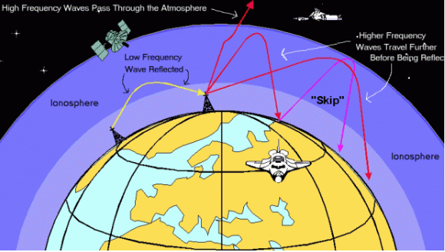

* Hot Iron’s Reference Data document is a library of tables and other information needed when working with electronics. Rather than repeating these many pages in every Hot Iron edition, we have elected to put them in a separate document which you can access here. As examples, there is an informative section on “Everything to Know About Wire,” an excellent section on the proper use of X-Y Capacitors on AC lines and much more.

* How does an RF choke work? Frank never thought to understand WHY an RF choke works; only that it does. Well, here’s why it works: When an AC voltage is applied across a coil, the voltage creates a changing magnetic field around the coil. This changing magnetic field around the coil induces a voltage in the coil that is opposite to the current flowing through it. This opposing voltage is known as back EMF (electromotive force). An RF voltage is a high-frequency AC voltage. At very low frequencies, (like 60 cycle AC), there is little back EMF and the coil acts like a wire. At higher frequencies the back EMF increases enough that it opposes the RF input current. Think of the filament choke employed in a grounded grid linear amplifier. Its purpose is to prevent RF from going into the filament transformer and doing bad things, while allowing free passage to the low frequency AC. On 80 meters, 10 to 14 uH might generate sufficient back EMF to block the RF but on the lower frequency of 160 meters, something like 28-30 uH will be needed. Perhaps two million uH (2 Henrys) would be needed to block a 60 cycle AC current (think ripple in linear power supplies).

* How to bend PVC tube for your projects? A novel way is demonstrated in this video! W4NPN has also had success heating it in the oven and then bending it. Note that this video is followed by other videos about various PVC techniques, so if PVC is a favorite material, these videos are for you!

* All about coax cable: This article explains much about coax, line loss, how it can degrade your radiated power and presents a useful table of losses for each type of cable at varying frequencies.
A 3 dB loss cuts your power in half. Ouch!

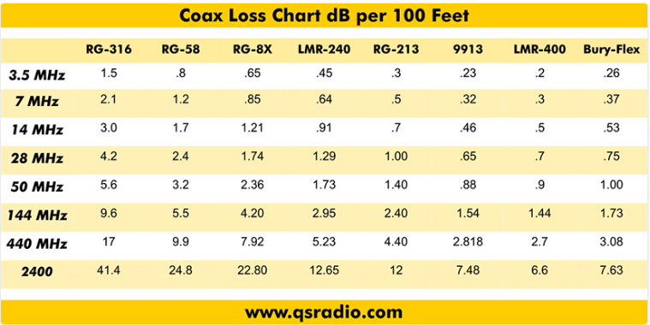

* Did you know? The twin Voyager satellites were launched 46 years ago to report on magnetic fields and charged particles in space. They travel at about 35,000 miles per hour and have left our solar system, moving into interstellar space, being about 24 billion km from earth. After 46 years they are still transmitting data back to earth! They are so far away that Voyager 1’s signals currently take about 20 hours to reach earth and Voyager 2’s take about 18 hours. It is amazing that 22 watt old technology, self-powered satellite transmitters continue to function after 46 years. They will eventually shut down as their electricity is made by radioisotope thermoelectric generators which continuously weaken.
* Ward, N0AX, has written an interesting paper about feeding EFHW antennas, which are quite popular these days.

* Amateur Radio Weekly, curated by K4HCK, is more news-oriented than construction-oriented, but every issue seems to have at least one construction-oriented project. You can link to the issues archive here. It’s free.

* The Random Wire is another ham-related website that Tom Salzer, KJ7T, operates. It addresses many facets of amateur radio, from high-tech to some construction techniques and seems to have something to everyone.

* Here’s a link to the ARRL newsletter, which has many pages of news of interest to us hams.

* DxZone publishes a substantial list of amateur radio newsletters. Have a look!

* The QRZ Forum contains news, technical information, discussions and equipment evaluations; there is much to read here!

* This DX Engineering website has 31 pages of news and general information about ham radio. Many antenna and feedline articles are included.

* Introduction to HF Packeteering in the Modern Age. This informative article by N6CTA provides everything one needs to know about the subject. The link was found on the latest issue of Amateur Radio Weekly.

* Why wire diameter is important. An interesting article on the Surrey Amateur Radio Communications web page.
* Zero Retries is an independent newsletter promoting technological innovation in Amateur Radio. The most recent edition has a number of articles of interest, including repurposing surplus portable light towers, SDR and much more.
* Check out www.w4npn.net, the website where the Hot Iron newsletters are hosted. There is much more there! Another rabbit hole.

Future Quarterly Newsletter Content – some subjects we are considering:

Crystals and Crystal Oscillators, a VFO issue, Regenerative Receiver designs, Classic Xmtr designs, Power Supplies. What interests you? Let us know!

Disclaimer: We have no ties with any commercial company mentioned in Hot Iron editions or on the w4npn.net website.
Please share Hot Iron with your friends and radio clubs, etc.! There is no cost and we do not share the address list with any other organization.

