August, 2023 Hot Iron Newsletter #121
If you’ve been a Hot Iron subscriber for long, you are aware of the large variety of material it brings to subscribers. Please send suggestions and articles, as well as the email addresses of new subscribers to fbw4npn@gmail.com. And send your technical questions to Peter Thornton at equieng@gmail.com
A Hot Iron website page contains the index of topics covered by the individual newsletters, where the number of the issue containing the subject of your interest can be found. These are an interesting read on a hot summer’s day (or a cold winter’s night).

Here begins Hot Iron’s August Newsletter, beginning with an informative article by Peter Thornton and containing some reprints from older issues:

Hunting QRM to Order!
QRM is a right b*~~er, it drives you mad - it comes from (seemingly) everywhere; it is a relentless problem that’s getting worse all the time. Sometimes a bit of methodical detective work can hush the gremlins; or maybe find a direction from which the noise is quietest. Try some - or all - the ideas below, which helped us when testing RF semiconductors.

Airborne, Earth borne or Wiring trouble?
QRM is RF noise; it can come from myriad sources - how do you find (and hopefully negate) the major culprits? Here are some simple checks that might help locate the QRM source.
- Does the QRM reduce if you try a Hertz (balanced) antenna, i.e. dipole or tuned loop?
If the QRM reduces, and is lower in some direction(s) the QRM is inducing equal and opposite currents in each dipole or loop leg, so the noise signals are cancelling (hopefully). Hertz antennas are directional - sorry, MW / LF fans, you’ll need some major real estate to do this down in the kHz!
- Does the QRM drop if you replace the antenna with a (non-inductive) 50 ohm resistor?
The only way ANY signal can get into the receiver with a matched (and shielded) 50 ohm resistor across the antenna input is via the power supply or by signals getting into the outer skin of the metallic case / conducting screens of your receiver, or coming up the power supply / Earth lead(s).
- Are you using a Marconi (unbalanced) antenna? Does the QRM reduce if you disconnect the Earth rod and use a ‘virtual’ earth - like a counter-wound (non-inductive) counterpoise?
You may have earth borne currents flowing in your area from other electrical installations nearby (and not so nearby - earth currents from distribution networks can travel many km’s!).
- Does the QRM reduce if you use battery (or DC power supply)?
I don’t mean “hum” or related 50 / 60Hz noise, I’m referring to wideband noise, not power supply related. Though the dreaded ‘direct conversion hum’ is a killer, that is another issue entirely from HF QRM which I’ll look at some other time.
Your receiver may be very sensitive to noise coming up the earth wire; the counterpoise (above) might indicate this too if the QRM significantly reduces.
- Disconnect your household electrical appliances one by one, see if the QRM drops
Good behaviour begins at home - YOU might be the source of local QRM!

Earth Noise: the insidious Demon
In most urban areas live other electrical equipment users; and all installations run currents into the earth, either deliberately or by induction or leakage. Remember you’re seeking μvolts of RF!
Delta connected capacitors in the ‘filter’ mains input sockets or other ‘noise elimination’ schemes run capacitors line to earth, neutral to earth and line to neutral: all these contribute to noise currents in the earth. The ‘true’ earth of your supply is the 3Φstar point in the substation feeding your house via cables, usually (but not always!) steel wire armoured and these induce 50 / 60Hz currents in their screens. Being VLF, skin effect is not present to any real extent so can’t contain the noise within the armouring; these currents despite magnetic steel armouring induce emf’s in the nearby ground and said ground being wet and salty, it conducts well, so the currents can run for many metres through the ground.
Similarly, AC power is distributed over the network with non-linear over voltage ‘Metrosils’ , ‘Transorbs’ connected to absorb over-volt surges. These cut transients, thus, as Mr. Fourier’s analysis tells, make for HF harmonics. It’s common to ‘tap change’ transformers on load using ballast inductors to limit short circuit currents, but these inductors carry huge currents, and are rapidly switched in and out causing back emf surges (Lenz’s Law).
To eliminate problems like this in industry, it’s common for ‘electrically’ clean rooms in semiconductor test halls to use Earth free Faraday cages, where the AC power is fed into a conductive walled room via 230v to 230v isolating transformers with substantial line-to-line filtering, using Class X capacitors and heavy common mode chokes - as no Earth connection is allowed inside. I don’t think a full Faraday cage in a domestic environment would be acceptable to your XYL(!!); ¾” wire netting lining can be an efficient RF screen in a garden shack. Faraday’s law assures that charges can only exist on the outside of an enclosure, and that includes QRM.
The only route in for QRM is via mains wiring entering your Faraday cage - and if this is via isolating transformer(s) and substantial line filtering creates ‘double insulated Earth free’ supply inside the cage, though this is often beyond the average amateur’s means (and your local Sparky’s experience) and needs serious safety considerations. Almost any radio gear can be run inside a Faraday cage on DC supplies; burglar alarm batteries are an option (but charged outside the cage).

The cheap & cheerful way forward
- Find the source and eliminate it (a directional loop antenna can help here and look for noisy / sparking commutators in electric motors, SCR dimmer switches, etc.) and try snubber networks (low ohms resistors in series with μF’s are commercially available for this job) across AC Line 1 to AC Line 2 of the offending supply or item. This can often entail ‘delicate’ conversations with neighbours who might have no idea they are blotting out acres of radio reception.
- Shield out air borne noise with screening cages (galvanised wire mesh with ½” or ¾” holes is solder-able and can form effective screening, even if not a completely closed volume).
- Balanced Hertz antennas cancel common mode noise (loops, folded dipoles, in fact any Hertz antenna that needs no earth connection) and can help with QRM reduction.
- For Marconi antennas, try counterpoise grounds (not connected to a ground rod!) to eliminate Earth borne noise (try twin core flex (a.k.a. Zip Cord) shorted at the far end, and only connect one core to the receiver so clockwise turns always have an equal counter-clockwise partner).
- Establish a time and date record of the QRM. (It might tie in with a local factory start time, a neighbour’s lawn mower, or another regular onset. Any pattern helps find the source.)
There is no guaranteed technique to eliminate QRM, but these industrial practices adapted to domestic environs usually reduce the bother. If all else fails, consider VHF / UHF: 6m and up can be noticeably QRM clear with only electronic shot noise to contend with - and effective bandpass audio filtering can work wonders shifting most of that.

Donder und Blitzen - Station Grounding: Grounding information can be integrated with Peter’s information about QRM, presented above. Such information might be helpful, both in terms of QRM reduction, ground loops and safety – see below.
Be sure to read W8JI’s web page concerning station grounding, which explains different paths lightning can take to wreak havoc on your equipment. Suitable grounding is needed, especially in certain lightning-prone areas. W4NPN’s first home in North Carolina was hit twice; the first time it exploded a 100+ year-old Poplar tree ten feet from the house, throwing bits of it over 300 feet away and the second time it slightly charred a few rafters. Both times resulted in some commercial equipment loss (but the tube ham gear survived). Yes, I moved to a different home, and yes, it really gets your attention when it happens at 2 AM.

Click here for the ARRL’s notes on station grounding.

The Smoky Mountain Amateur Radio Club has a good web-based publication regarding station grounding.

What’s a SNUBBER? A snubber network was mentioned above. What’s a snubber? Go here to find out.
A Simple Doublet Antenna, Field Strength Meter, 1:1 balun:
Google reports 8,210,000 “HF Antenna” articles but “only” 204,000 ( ! ) are about doublets. Some are good, some are bad and some are Goldilocks antennas – “just right.” For those with restricted horizontal space, Hot Iron #66 contains one originally designed by G3OOU and submitted by G4CWX. Feed it with low-loss “ladder line” and terminate it at the antenna tuner with a 1:1 or 4:1 Guanella (i.e., current) balun (whichever ratio works for you, 1:1 being slightly preferred):
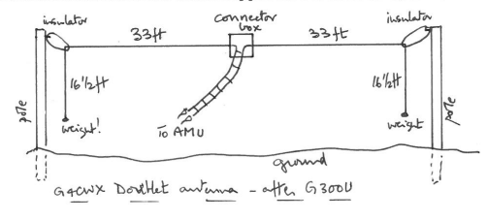

Its impedance will of course be different on each band and a good tuner match will likely be found by trial and error, unless some sophisticated equipment is at hand. I think this one works on 40 meters and higher bands. Be sure to avoid a “wrong” length of ladder line. See information about that here.
W4RNL (SK) has also described one hung vertically, with 20 foot legs on either side, and fed with ladder line. W4NPN just installed one of these to play with and will soon test it, comparing it to a 137 foot Vee on receive/transmit and a 450 foot ground loop for receiving.

This information can be applied to any ordinary wire doublet or dipole. See this Antenna Page.

A field strength meter is a handy gadget for ensuring that the antenna is radiating. A circuit for a simple FSM, from the Sept 2002 QST is below. The meter could be 50, 100, 200 ua, etc. and the antenna can be a short length of wire or one rescued from a discarded radio.

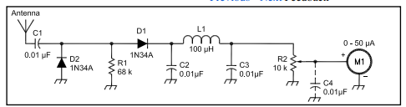

Note that, if an L-C circuit is installed directly after the antenna, and tuned to the desired band, you can be sure that the L-C “tune” circuit of the transmitter’s tank circuit is tuned to the correct band and that radiation to the wrong band is not occurring. Of course, you can do the same thing with your receiver.

A Simple Current Balun:
Jerry Sevick’s (W2FMI, SK) designs for 1:1 current baluns are below (source: April ‘94 CQ magazine, illustration H). Mine are wound on a T200-2 core, using #14 (1.628 mm) insulated house wire. Since I used insulated wire on a bare core, I added one more turn. My windings use the full circumference of the 2” toroid and both my homebrew tuners like it on 80 – 10 meters.
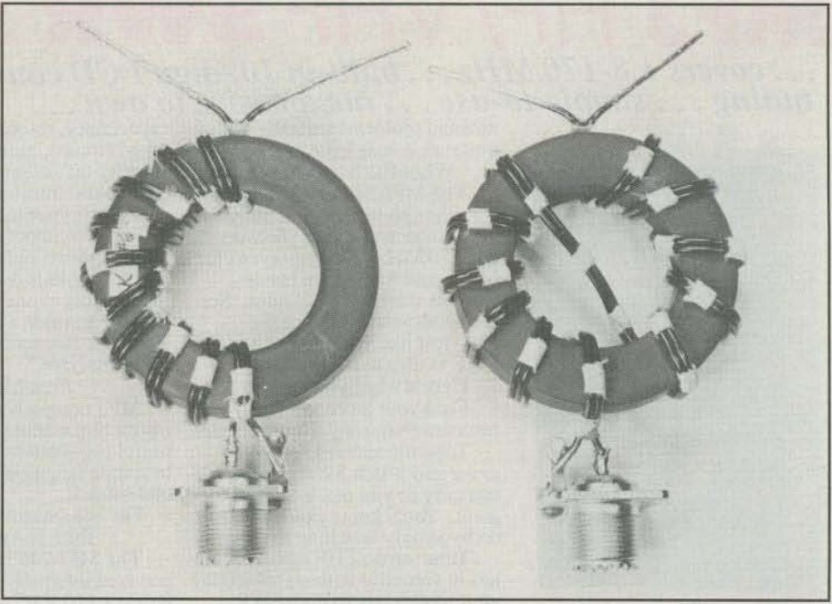

There is a huge amount of Web info about baluns; some good and some not so good. Try this page to get started. I am no expert whatsoever on baluns, no matter how much I read, so I rely on experts like Sevick. And finally, much information about Ladder Line (a.k.a. twinlead) can be found here.
Read Peter Thornton’s QRM article at the begining of this newsletter: Man-made QRM was so bad at my QTH’s inverted Vee (from computers and other radiating gear) that I laid a large loop directly on the ground and fed it with 450-ohm “ladder line.” The noise reduction was dramatic and very little signal strength was lost. The improvement in signal-to-noise-ratio was excellent. If you are in the same situation, consider a ground loop for receiving. They can even be made somewhat directional. Google “loop on ground antenna” for information. Mine is 450’ because I converted a large, very low level random wire into an on-ground loop. A 60 to 100 foot loop is quite adequate. Just run it around the border of your garden or back yard.
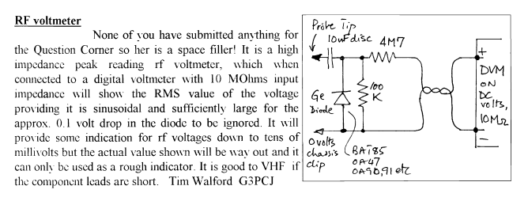
Perhaps some clever person will figure out how to integrate this RF vm into the Field Strength Meter circuit, as a switchable option, using the installed meter, calibrated for volts.
Crystal Oscillator/Frequency Standard (Hot Iron #33):
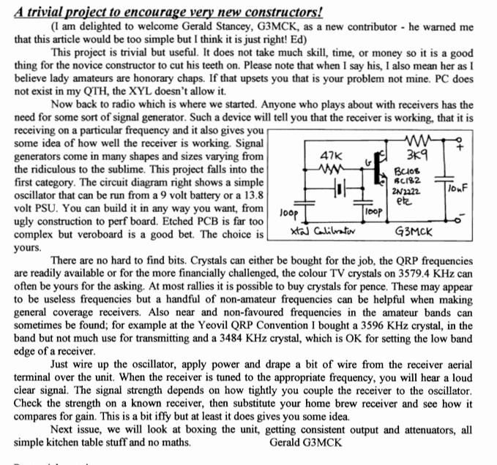

More about Oscillators: An excellent book about oscillators of all types is the extensive John Rider book Oscillators at work. A copy may be found here and this web page also has many articles about crystals and their operation, grinding, pushing and pulling, etc.

Have a mystery transformer? Go to this website to find manufacturer’s catalogs which might solve the mystery.

Future issues: Thousands of regenerative receivers have been built; even my father built them back in the 1920’s (wow, that was 100 years ago, and so was he!). They are great fun! A future issue of Hot Iron will have some concentration on the subject. Please send any information or comments you might have about regens, including your favorite designs, to W4NPN.

I’m thinking of a possible concentration on simple VFO’s in a future issue as well. Perhaps some chassis manufacturing articles; maybe simple tuners. Maybe even a few digital or SDR thoughts. Suggestions are welcome.

A listing of good ham-related websites might make a good subject so suggestions about these would be welcome. See what’s already available on this page.
This is all for this issue; please send your articles of interest and suggestions to me or Peter at the email addresses contained in the introduction. I will continue to troll through back issues for articles that seem to merit repetition and will look for new topics on the great Web. I wish I could find time to work on my own projects (retirement is SO BUSY)!

