End Fed Half Wave Antenna miscellaneous info:

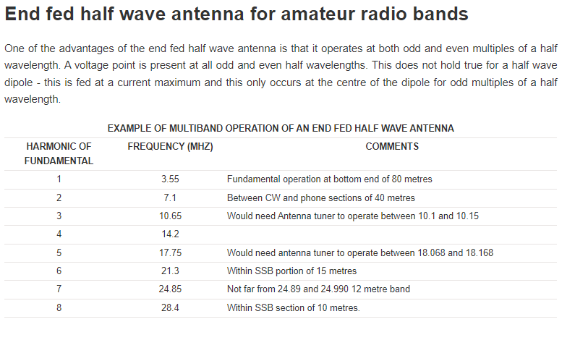
Length = 463/freq

Example: for 3.55 mhz, length would be 125.2 feet

If the lowest band to be used is 40 meters, the length would be 463/7.1 = 65.2 feet.

At its fundamental frequency where it is a half wave, the radiation pattern will be broadside to the antenna, like a dipole.

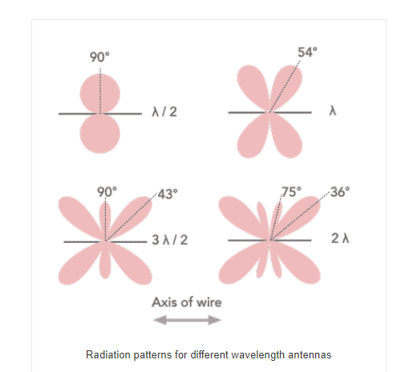
As the frequency is increased, the radiation pattern will move closer to the longitudinal axis of the antenna:

The feed point impedance of the antenna will vary with frequency and might vary from 1800 to be as much as 5,000 ohms. For this reason, it is best to use a 1:49 unun.

A counterpoise is strongly recommended.

Here is a good article about EFHW antennas:
http://nx0g.org/miscfiles/Understanding%20the%20EFHW.pdf

